May 2023
Exploring mental health in communities
A facilitator guide

AMY KIRWAN, SAMSAM GEEREH, VIV MAH, ANA OROZCO
Contents

Acknowledgements 3
Who this guide is for 4
How to use this guide 4
About VOICE 5
About the project 5
Workshop aims and activities 6
Initial briefing 7
Activity 1 - Introductions and icebreakers 8
Activity 1 Worksheet A 9
Image bank 10
Activity 2 – What does mental health mean to us? 11
Activity 2 Worksheet A – Psychological wellbeing definitions for different groups 13
Activity 2 Worksheet B – Mental health word bank 16
Image bank 17
Activity 3 – Our town: a strong and supportive community 18
Activity 3 Worksheet A – Mental health needs of different groups 19
Activity 3 Worksheet B – Our town activity guidance 20
Image bank 21
Activity 4 – Expanding the city limits by sharing what we have created 22
Activity 4 Worksheet A – Expanding city limits activity guidance 23
Image bank 24
Activity 5 - Evaluation 25
Activity 5 Worksheet A 26
Activity 5 Worksheet B 28
Activity 6 - Post-workshop planning and delivering to a wider audience 30
References 32

Acknowledgements
The authors of this guide acknowledge the Boon Wurrung and Wurndjeri Woi Wurrung people of the Kulin nation as the traditional owners and custodians of the land where we live and work and recognise their strong and ongoing connection to land, waters and community. Sovereignty was never ceded.
This project was developed in collaboration between Burnet Institute, Australian Multicultural Foundation, Islamic Museum of Australia and Your Community Health. We acknowledge all contributors to the project who gave their time and expertise and members of the Muslim community in Darebin who shared their experiences with our team.
We also wish to acknowledge the contributions of Preston Mosque and the Centre for Muslim Wellbeing.

Who this guide is for
This guide is for workers who are interested in better understanding a community’s feelings and needs regarding mental health. Some of the circumstances in which you might use this guide include if:
- You’ve noticed more clients reporting mental health concerns
- You know the community you work with has struggled with issues around mental health
- You know the community you work with holds unaddressed stigma towards mental health
- You’re developing a program or content around mental health.

How to use this guide
This guide sets out a series of five activities workers can use to understand and proactively address a community’s feelings towards mental health. We recommend that these activities are run in an in-person workshop setting, but they can be adapted into other formats.
Each activity page includes information on:
- What the activity involves
- What its aims are
- What you’ll learn from each activity
- Detailed descriptions of how to run the activity
- What resources you will need
Finally, at the end of this guide, you’ll find worksheets, prompts and other resources we created (and tested with communities) to support you in running these workshops effectively. These resources aren’t meant to limit you – but rather, inspire you.
Feel free to use these, build on them to create something new, or come up with your own thing altogether!
We would love to hear about how you have used and adapted them and any feedback you would like us to incorporate into the resources to improve them.
Email us at voice@burnet.edu.au

About VOICE
VOICE is a Victorian Ongoing Initiative for Community Engagement. It is a program run by the Burnet Institute, with funding support from the Victorian Department of Families, Fairness and Housing.
VOICE’s goal is that the voice and needs of multicultural communities are heard, acknowledged, and holistically addressed by those who can help. Our vision is to:
- Ensure multicultural community public health needs are understood and addressed
- Provide frameworks and tools which can identify and respond to emerging challenges and rapidly-evolving issues, like floods, pandemics and fires
- Understand and create the right conditions for meaningful cross-sectoral learning and information sharing
- Create timely, evidence-based resources and support for multicultural community service providers.
Our digital platform can be found at www.voiceonline.org.au.

About the project
In 2023, the Burnet Institute and its project partners Your Community Health, the Islamic Museum of Australia and the Australian Multicultural Foundation collaborated on developing an intervention for the Muslim community based in Darebin. Research had revealed that this community were disengaged with pandemic related communications; and a further survey, which received 61 responses, revealed that this community were experiencing struggles with their mental health, social connectedness, ability to care for their families and their financial stability.
The Burnet Institute and its project partners used this information to develop a co design process (which led to the creation of the activities in this guide), which in turn assisted the project partners in developing a responsive public health intervention.
While the intervention was developed for and with members of the Muslim community in Darebin, the activities have been further developed following implementation so that they can be delivered in other communities. This development process has utilised knowledge and understandings developed in other similar projects run with multicultural communities.

Workshop aims and activities
This workshop aims to answer the question ‘How can we equip a community with better tools for good mental health?’
The aims of this series of activities are as follows:
- Developing mental health literacy and cultural understanding of mental health in the community
- Creatively developing a vision of a community which is supportive of mental health and wellbeing
- Creating messages and materials that can be shared with a wider audience in order to improve community mental health and wellbeing
Activity guides include the activity aim, objective, learning outcomes, supporting materials, suggested run times and step by step facilitator notes.
An image bank which includes photos taken at previous workshops and gives an indication of how previous workshop activities have been run is included with each activity.

Initial briefing

AIM
To inform workshop members what the workshop’s about, why it’s being run, and who it will be facilitated by.

OBJECTIVE
To begin to create a sense of comfort and understanding in the room and provide an opportunity for workshop participants to raise questions or concerns prior to workshop activities.

SUPPORTING MATERIAL
Slide deck

SUGGESTED RUN TIME
5 – 10 minutes

FACILITATOR NOTES
- Open with acknowledgement of country (slide deck)
- Introduce facilitators
- Provide housekeeping details
- Background of workshop
- Set the scene for workshop participants
- Let participants know what to expect in the workshop

Activity 1 - Introductions and icebreakers

AIM
To build a sense of warmth and safety in the room.

OBJECTIVE
Given that mental health can be a sensitive topic, this activity provides an opportunity for participants to learn more about one another and build a space of shared safety.

LEARNING OUTCOME
Participants know a bit about other participants and feel comfortable to proceed into more focused activities

SUPPORTING MATERIAL
Butcher’s paper to develop a group agreement, Activity 1 Worksheet A: Group agreement tip sheet (source https://www.bcna.org.au/media/2796/bcna-mg-kit-group-agreement.pdf), A4 sheets of paper, image bank

SUGGESTED RUN TIME
15 – 25 minutes

FACILITATOR NOTES
Step by step:
- Group discussion: What words come to mind when people use the term ‘wellbeing’?
- Additional questions to promote discussion:
  - What kinds of things can affect a positive sense of wellbeing, or throw it off balance?
  - Is wellbeing something that people need to learn how to ‘tune into’ only at certain times, or is it something we can help develop and nurture over a period of time?
- Each participant draw or write an item, place or activity that elicits a sense of wellbeing/self-care for them on an A4 sheet of paper
- Participants to introduce themselves and show and tell their activity with the group

Activity 1 Worksheet A
A group agreement is a clear set of guidelines on how your group will handle discussions, meetings, and sensitive information raised in the group setting. Whether you meet informally for coffee or for structured meetings, a group agreement is an important foundation that acknowledges each individual member’s right to respectful treatment.
When creating or reviewing your own group agreement with your members, use the below example to start the conversation. You may find that not all of the points below are relevant or that you have something you would like to add.
Below is an example of a group agreement from the Cancer Council booklet Cancer support groups: A guide to setting up and maintaining a group. Request a copy of the booklet from the Cancer Council on 13 11 20 or download a copy from their website www.cancercouncil.com.au.

Cancer Council’s example of a group agreement
- Everything discussed in the group is confidential. Individual identifying information is not shared outside the group.
- Group members are encouraged to share their skills, insights, strengths and hopes, and to recognise that everyone in group has expertise in dealing with cancer. Individual health professionals should not be named/identified.
- Group members are respectful of each others’ feelings, views and concerns at all times.
- Group members are respectful of everyone’s right to participate equally in the discussion or not to participate, if that is their wish.
- Group members are courteous to each other at all times. This includes not interrupting or talking while someone else is talking and listening attentively when another person is speaking.
- Group members take responsibility for the success of this support group by maintaining their focus on the issues and coping strategies specific to the group and the topic being discussed.
- Group members are encouraged to use ‘I’ statements so that everyone speaks in the first person.
- Group members are responsible for their own wellbeing and are encouraged to look after themselves and seek support if they are upset before, during or after group.

Source: https://www.bcna.org.au/media/2796/bcna-mg-kit-group-agreement.pdf

Image bank
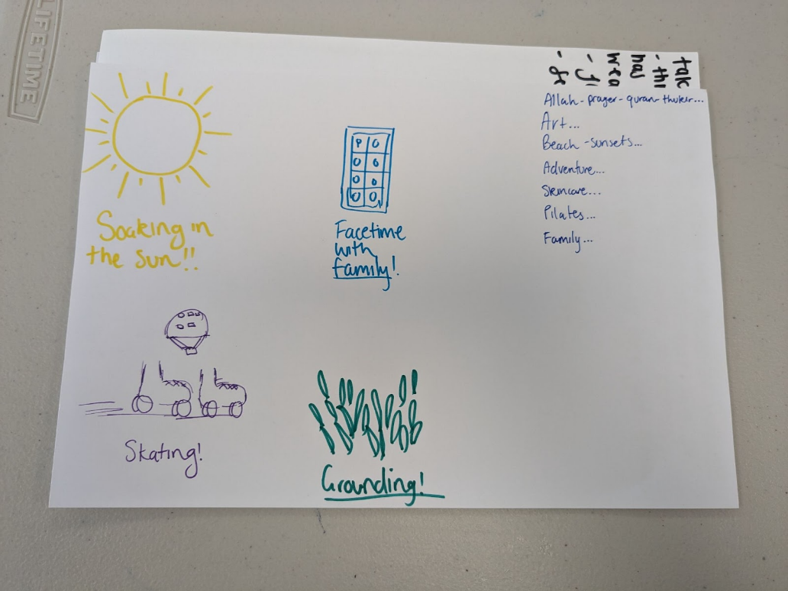
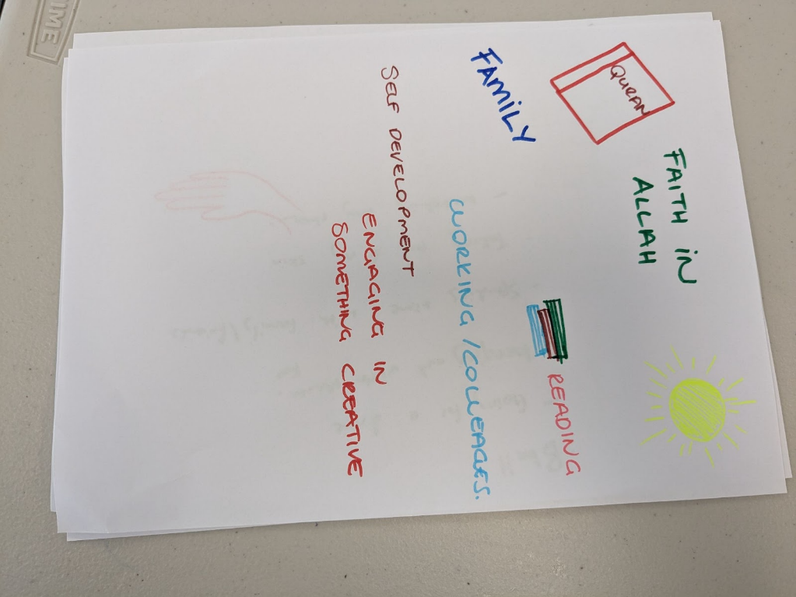

Activity 2 – What does mental health mean to us?

AIM
Develop mental health literacy and cultural understandings of psychological wellbeing in the community

OBJECTIVE
To share and reflect on definitions of mental health and to develop a culturally appropriate definition with the workshop attendees

LEARNING OUTCOME
- Participants feel safe to contribute to conversations and activities focused on mental health
- Participants can create their own culturally appropriate definition of mental health

SUPPORTING MATERIAL
Activity 2 Worksheets A and B, A2 sheets of paper, image bank

SUGGESTED RUN TIME
45 – 60 minutes

FACILITATOR NOTES
Step by step:
- Share and reflect on some selected definitions from Activity 2 Worksheet A as a group.
Prompting questions for discussion:
- What do you like and why?
- What don’t you like and why?
- Are there any keywords in the definitions that you think are important to keep? Why/why not?
- Are there any keywords in the definition that you’re not sure about and should be removed? Why/why not?
- Facilitator to take notes of discussion for reflection/evaluation
- Break the participants up into small groups (ideally 2-3 participants)
- Share Activity 2 Worksheet A (can edit down to a shorter version) with participants, which demonstrate how different groups interpreted the activity and created their own definitions. Worksheet B can be offered as a further resource or more simple version for participants to draw from.
- Each group to develop a culturally appropriate definition of mental health
- Ask groups to appoint a scribe and a spokesperson and let them know how much time they have
- Groups to share back
- Debrief the activity by asking participants to share what they liked about other group’s interpretations of the activity
Prompting questions for discussion:
- Ask participants how they understand mental health in the context of a particular definition
- Ask participants what can demonstrate that someone may not be experiencing wellbeing or whose mental health is not good. Facilitators explore the concept of a spectrum of mental health and some symptoms
- Use butcher’s paper/whiteboarding to record the share back and discussion on mental health
- Provide opportunities to record discussions or outputs from this activity (e.g. video, audio, photography, written notes) to contribute to creation of materials for community dissemination

Activity 2 Worksheet A – Psychological wellbeing definitions for different groups

These definitions were initially co-designed with service providers, community leaders and young people. Workshop participants from different demographic groups then adapted the co-designed definitions according to their own interpretation. Any or all of these may be used to support participants in your workshop to create their own definitions.

ADULT WOMEN
CO-DESIGNED DEFINITION | WORKSHOP PARTICIPANT DEFINITION
1.Having a sense of financial security to meet needs and demands in life | Achieving financial security to meet needs and demands in life  Having a sense of security in all aspects of life (emotionally and financially) to meet needs and demands in life which as a result positively impacts our sense of wellbeing
2.Finding a sense of purpose through spirituality and connection to Islam | Having a sense of security and purpose through spirituality and connection to Islam
3.Building a healthy self image | Building a healthy sense of image for oneself  Building a healthy self esteem by taking care of oneself mentally, physically and emotionally
4.The ability to manage and respond to emotional experiences | The ability to proactively manage and mindfully respond to emotional experiences with the right supports  The ability to respond to emotional experiences with the right supports that can help you manage it more effectively
5.Having the emotional strength to cope and recover from trauma, adversity and hardship | Developing emotional strength and culturally appropriate supports to cope and recover from trauma, adversity and hardship  Developing emotional strength and providing culturally appropriate care and supports to cope and recover from trauma, adversity and hardship

ADULT MEN
CO-DESIGNED DEFINITION | WORKSHOP PARTICIPANT DEFINITION
1.Having a sense of financial security to meet needs and demands in life | Recognising that people living with mental health challenges may also experience other forms of hardships and cope differently
2.Finding a sense of purpose through spirituality and connection to Islam | No change suggested
3.Building a healthy self image | Knowing and recognising that building a healthy self image is primarily based on an individual’s personal feelings and perspectives
4.The ability to manage and respond to emotional experiences | Develop skills and the ability to manage and respond to emotional experiences  The ability to manage and respond to your emotional experiences
5.Having the emotional strength to cope and recover from trauma, adversity and hardship | Developing the emotional strength to cope with psychological issues comes from a person’s ability to understand their lived experience and educational supports

YOUNG WOMEN
CO-DESIGNED DEFINITION | WORKSHOP PARTICIPANT DEFINITION
1.Having a sense of financial security to meet needs and demands in life | The ability to feel safe, secure and stable in all aspects of life to meet needs and demands in life  Recognising the importance of having a sense of stability and financial security to meet needs and demands/expectations in life
2.Finding a sense of purpose through spirituality and connection to Islam | Guiding your sense of purpose through spirituality and connection to Islam
3.Building a healthy self image | Building a healthy mindset and a balanced sense of self
4.The ability to manage and respond to emotional experiences | Recognising and managing emotional experiences  Understanding and recognising the need to work on healthy coping skills to manage and respond to emotional experiences  Having the right supports in place to be able to manage and respond to emotional experiences
5.Having the emotional strength to cope and recover from trauma, adversity and hardship | An overall sense of wellness will not be achieved without having a balance in these key elements: physical, emotional, spiritual, economic, social and culture

Activity 2 Worksheet B – Mental health word bank

These are examples of words that participants may want to utilise in their own definitions. These may be used in addition to or as an alternative to the more detailed definitions in the previous worksheet.
CONTENTMENT | CULTURALLY APPROPRIATE | SATISFIED | EMOTIONAL REGULATION
HAPPINESS | SECURITY | HOLISTIC | BALANCE
DISTRESS | PURPOSE | MINDFULNESS | STABLE
PHYSICAL HEALTH | FUNCTIONING | BELONGING | GROWTH
MENTAL HEALTH | COPING | SAFE | SELF-ACCEPTANCE
POSITIVE | RESILIENCE | SECURITY | CONSISTENT
SUPPORTS | GRATITUDE | SPIRITUALITY | FEELING GOOD

Image bank
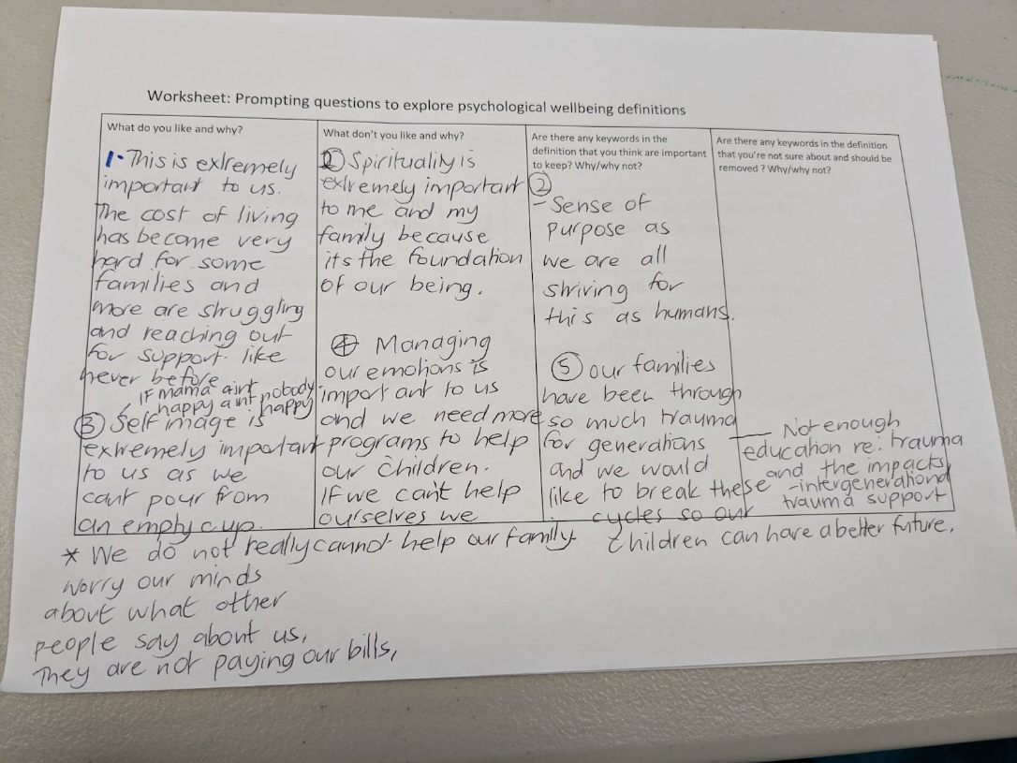
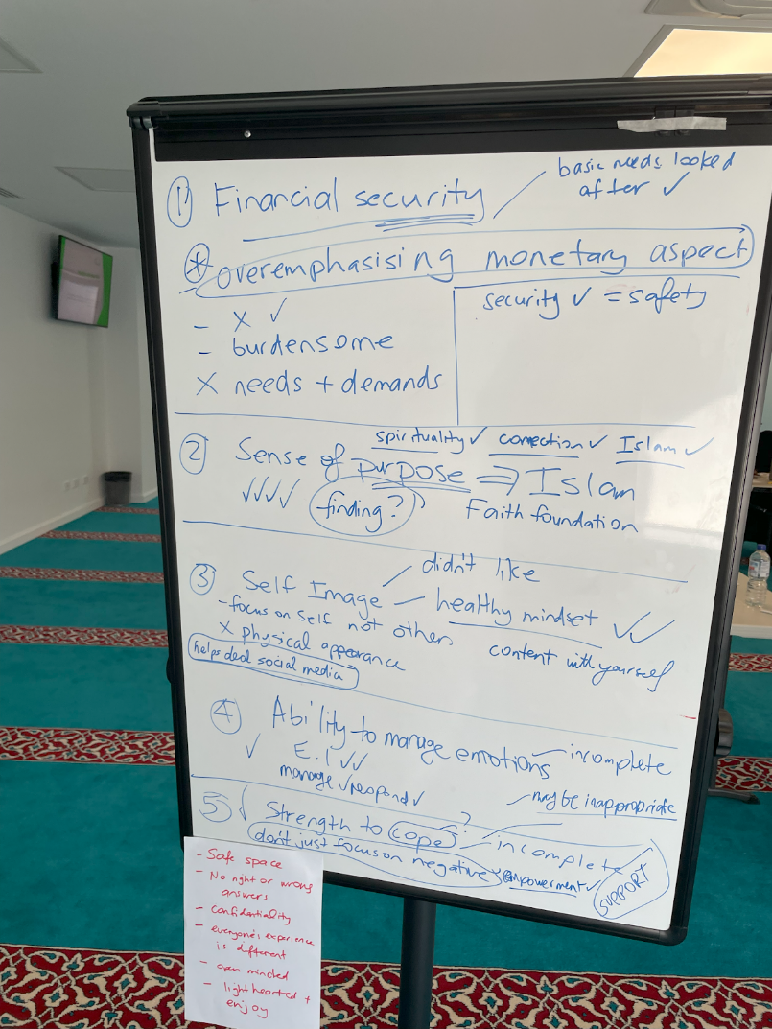

Activity 3 – Our town: a strong and supportive community

AIM
Creatively develop a picture of a community which is supportive of mental health and wellbeing

OBJECTIVE
Identify components of a healthy community and how they may be accessed and situated, including incorporating existing supports

LEARNING OUTCOMES
- Participants will be able to communicate community mental health needs and challenges.
- Participants will build nuanced understandings of mental health and place them in the context of their own local community

SUPPORTING MATERIAL
Activity 3 Worksheet A and B, craft materials, A3 sheets of paper, Butcher’s paper, textas, your own list of potential supports and services that exist in your community, image bank

SUGGESTED RUN TIME
75 minutes

FACILITATOR NOTES
Step by step:
- Begin by sharing Activity 3 Worksheet A and facilitate brief discussion on whether participants feel the mental health needs resonate with them, following on from discussion in the previous activity, and see if there is anything they would like to add or remove
- Ask participants where people can access supports for mental health in their community currently and scribe these on a whiteboard
- Brainstorm key places participants would like to access mental health supports in their community on an A3 sheet or whiteboard
- Introduce our town concept and the crafting materials
- Provide groups with worksheet Activity 3 worksheet B ‘ Our town activity guidance’
- Offer a list of potential supports and services that already exist in the community and ask them to include them in their town if they like them and think they or someone else they know would use them
- Brief participants that there are no wrong things to build and to get creative in how they think their community could be stronger and more supportive of mental health
- Brief participants to generate as many ideas as they can within the timeframe
- Facilitators to spend time visiting each group and seeing how they are going, as well as offering suggestions or questions to guide further creation, particularly if some of the identified needs haven’t been addressed
- Provide opportunities to record discussions or outputs from this activity (e.g. video, audio, photography, written notes) to contribute to creation of materials for community dissemination

Activity 3 Worksheet A – Mental health needs of different groups

UNDERSTANDING MENTAL HEALTH NEEDS OF YOUNG PEOPLE
- Minimising harmful effects of social media toxicity and developing a stronger sense of self
- Managing intergenerational expectations and trauma such as unnecessary pressures set in schooling by parents and teachers
- Dealing with intergenerational trauma and overcoming stigma with mental illness
- The need to create awareness of culturally sensitive inclusive services, addressing unemployment, equipping schools to better support student’s mental health needs and combat discrimination
- Promote and improve physical wellbeing to maintain a healthy quality of life
- Developing positive role models through mentorship and better support in communicating mental health needs
- Raising awarness of situations that could seem normal in their household (e.g., family violence)

UNDERSTANDING MENTAL HEALTH NEEDS OF PARENTS
- Challenging social comparison/status, focusing on identity and sense of self considering language barriers,and different cultures and current beliefs
- Suggestions included encouraging community engagement such as group activities and conversations with other parents
- Managing cultural expectations/ gender roles, and challenging shame and stigma
- Addressing systemic issues including making accessible and easily understandable the information on general and culturally relevant services and opportunities available

Activity 3 Worksheet B – Our town activity guidance

PROMPTING QUESTIONS
- What do you think is needed to improve mental health and build a strong and supportive community?

- Reflect on the needs that have just been shared; what could be built to meet them?

- How and where might you like to seek help if you needed it?

- How might you use spaces and supports to help you or someone you know?

- What are the biggest challenges?

- How might we creatively respond to these challenges?

- How might we use community strengths to help us?

Image bank
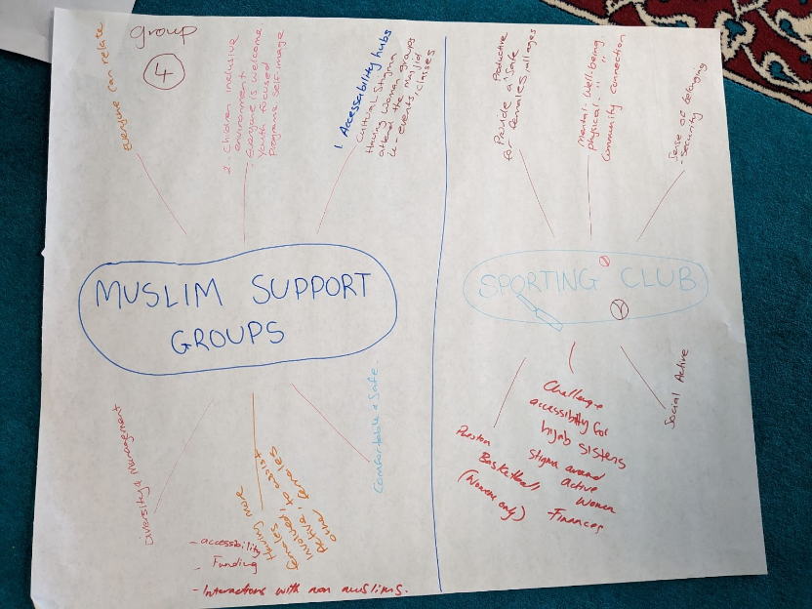
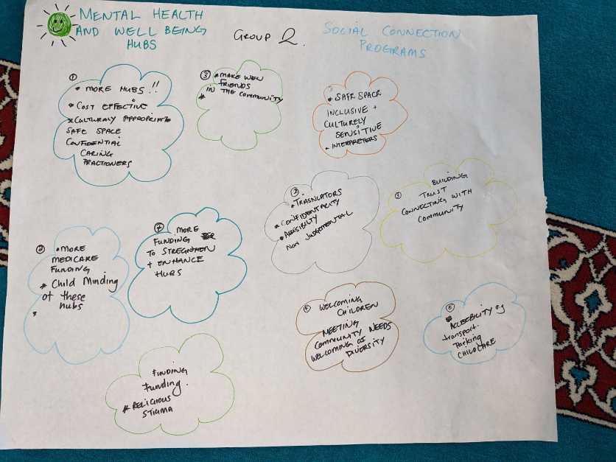
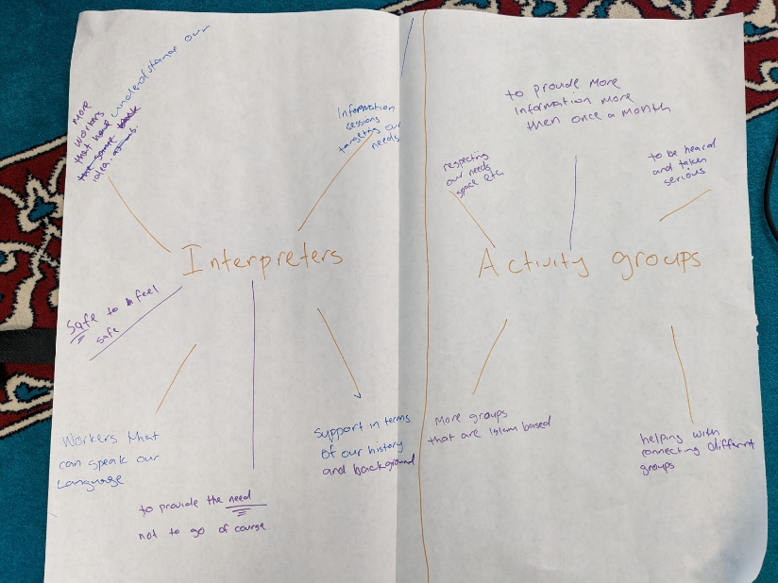

Activity 4 – Expanding the city limits by sharing what we have created

AIM
Expand the vision for a healthy community developed in small groups in the previous activity

OBJECTIVE
To compare and contrast different towns created in Activity 3 and reflect on how they could be strengthened

LEARNING OUTCOMES
Participants can act as mental health champions in their own communities

SUPPORTING MATERIAL
Activity 4 Worksheet A, image bank

SUGGESTED RUN TIME
40 – 45 minutes

FACILITATOR NOTES
Step by step:
- Groups to be provided with Activity 4 Worksheet A ‘expanding city limits guidance’ that can be used report back to the entire group
- Groups given 15 minutes to consult with one another and fill out the sheet
- Each group to report back
- Once all groups have shared their town, facilitators to lead discussion on:
- Similarities and differences between the towns
- What participants liked most about other group’s towns
- Whether there are some ideas that could be combined from the different towns to make a bigger or better idea that is more likely to succeed
- As a group, debrief the activity by undertaking a whiteboard activity to summarise strengths, challenges and opportunities for what the facilitators and partner organisations could do after the workshop to share what has been created and engage in advocacy where relevant
- Provide opportunities to record discussions or outputs from this activity (e.g. video, audio, photography, written notes) to contribute to creation of materials for community dissemination

Activity 4 Worksheet A – Expanding city limits activity guidance

PROMPTING QUESTIONS

- What were the strongest parts of your town and why?

- What was the most interesting or innovative thing that you built?

- What’s the thing you think will have the best chance of succeeding and why?

- What’s the thing you think might not succeed and why?

- Were you able to build something to address all of the needs that were shared at the beginning?

- If not, what was left and why?

Image bank
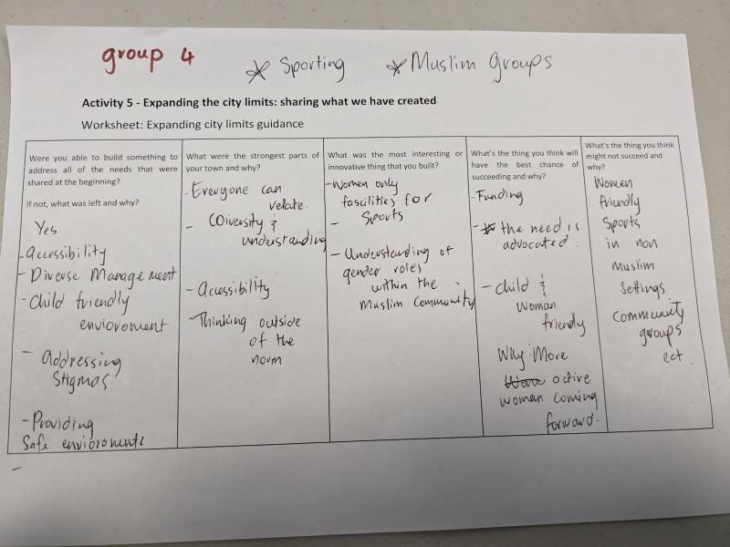
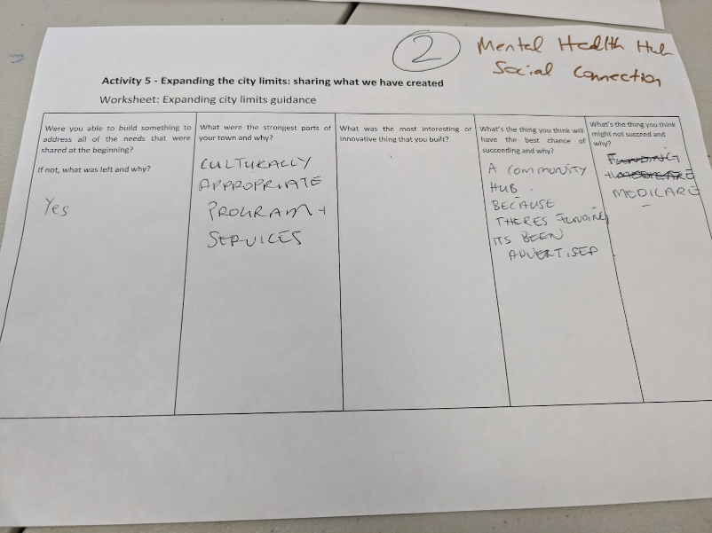
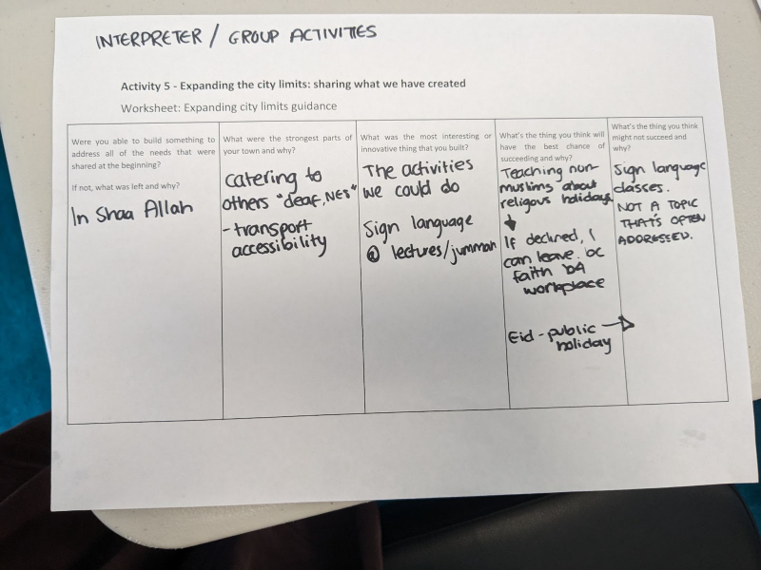

Activity 5 - Evaluation

AIM
Understanding participant experiences to improve the quality and impact of the workshop for future delivery

OBJECTIVE
Collecting data to measure experience and impact of activities

LEARNING OUTCOMES
Organisations can incorporate evaluation feedback to inform next steps in project delivery

SUPPORTING MATERIAL
Activity 5 Worksheet A - Participant surveys, Activity 5 Worksheet B - Facilitated group evaluation tools, craft materials

SUGGESTED RUN TIME
10 minutes

FACILITATOR NOTES
Step by step:
- Provide participants with individual written surveys to complete and hand in to a facilitator
- Facilitate discussion with the group as a whole on their experiences in the workshop and any improvements they would like to see in future delivery, using one of the group evaluation tools

Activity 5 Worksheet A

Source: Adapted from Bartlett et al., 2021

PARTICIPANT SURVEY FEEDBACK FORM
AT THE SESSION… | STRONGLY DISAGREE | DISAGREE | NEITHER DISAGREE OR AGREE | AGREE | STRONGLY AGREE | N/A
The group work felt collaborative
My contribution was valued
The roles and responsibilities of my participation were clearly defined
I understood both the processes and the language used
My time participating was compensated appropriately
I felt respected by the facilitators and organisers
I felt respected by the other participants
The group dynamics were appropriately managed
I believe the work undertaken was important
There were strategies to involve people with different communication needs
There was enough time to allow relationship building
Facilitators made attempts to reduce any power imbalance (e.g. between health professionals and community members)
I felt safe sharing my opinions
I would participate in another session with the facilitators
I would encourage others to participate in a session with the facilitators
I see my ideas and contributions reflected in the final product or output (optional)
The facilitators made me aware of any outputs or products after the sessions were completed (optional)

Tell us anything additional that will help us to improve similar workshops in the future?

Activity 5 Worksheet B

Sub-heading (Heading 2) introductory sentence here

STOP START CONTINUE
Start  What should we start doing? | Things that we are not doing, but should be  New ideas  New ways to address emerging issues
Stop  What should we stop doing? | Things that are not working  Things that are not having the desired outcome  Things that have been impractical  Things that we dislike
Continue  What should we keep doing? | Things that are working well that we want to keep doing  Things that we like  Parts of activities that we like, even if we don’t like the whole activity

KALM – KEEP, ADD, MORE, LESS
ADD  [Sticky notes] | More  [Sticky notes]
Keep
[Sticky notes]
Less
[Sticky notes]

ROSE, BUD, THORN
Rose = something that is working well or something positive
Bud = an area of opportunity or idea yet to be explored
Thorn = something that isn’t working or something negative
Rose | Bud | Thorn
What was the highlight?  What did you like?  Describe efforts that blossomed.  What are you most proud of? | What went wrong?  What was most stressful?  Identify causes of difficulty  What impeded your efforts?  What makes you worry? | What are you looking forward to?  Describe opportunities that energise you  What possibilities need growth and nurturing?
[Sticky notes] | [Sticky notes] | [Sticky notes]
[Sticky notes] | [Sticky notes] | [Sticky notes]

Activity 6 - Post-workshop planning and delivering to a wider audience

AIM
Creating messages and materials from the workshop that can be shared with a wider audience in order to improve community mental health and wellbeing

OBJECTIVE
To produce workshop outputs, such as video, audio, photography, and/or a report

LEARNING OUTCOMES
Organisations have community-specific mental health content which can be adapted and disseminated

SUPPORTING MATERIAL
Outputs from workshops including video, audio, photography and written notes; synthesis from co-design activity on successful health promotion messages and approaches; communications plan template

SUGGESTED RUN TIME
This will likely take a number of days following workshop completion

FACILITATOR NOTES
It is important to determine the most appropriate ways to record workshop outputs, dependent upon available skills, equipment and resources for post-production (e.g. photo or video editing, graphic design). This can ensure that recording is done in the most practicable way to lead to products which can be shared more widely.
Following workshop delivery, facilitators, partners and others (may include workshop participants if they would like to be involved) will explore workshop outputs and develop a plan to disseminate these outputs to the broader community.
This plan should detail whether further synthesis or development of outputs is required before they can be shared more widely. Activities undertaken will be largely dependent upon time and budgetary constraints. Opportunities to synthesise outputs from workshops delivered to different audiences may assist in consolidating the outputs into clearer ideas and identifying where specific messages or outputs could be tailored for different audiences.
Suggested activities could include:
- Creation of tiles for social media posts to be shared on organisation social media channels
- Creation of short videos of participant experiences or physical outputs from activities (e.g. towns)
- Development of a brief paper to inform advocacy activities for funding, service availability or development of capacity or capability within the community
- Working with an illustrator to create a visually appealing representation of the ‘towns’ that were created during the workshops
- Tailoring social media campaigns for young people or adults, if outputs from the different participants was divergent around needs and potential supports
- Collaborating with other community leaders, groups and stakeholders to disseminate materials to the community, including through activities like support groups or community events

References
Bartlett, R., Boyle, J. A., Simons Smith, J., Khan, N., Robinson, T., & Ramaswamy, R. (2021). Evaluating human-centred design for public health: a case study on developing a healthcare app with refugee communities. Research Involvement and Engagement, 7(1), 32. https://doi.org/10.1186/s40900-021-00273-2
Breast Cancer Network Australia. Group Agreement Tip Sheet. https://www.bcna.org.au/media/4339/group-agreement-tip-sheet.pdf
Burnet Institute. (2022). Darebin Muslim Community Survey Results https://voiceonline.org.au/resources/darebin-muslim-community-survey-2022-results/
Burnet Institute. (2023). voiceonline.org.au

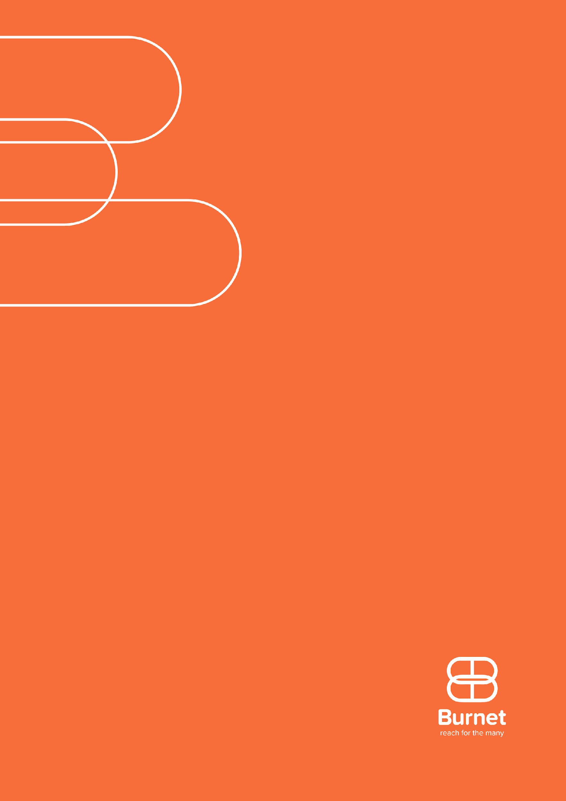

AUSTRALIA

85 Commercial Road
Melbourne, Victoria, 3004
t + 61 3 9282 2111
e info@burnet.edu.au
OVERSEAS

We have offices or representatives in Australia, Papua New Guinea
and Myanmar, and also contribute to activities in other Asian, Pacific and African countries.

For more information, contact us
at info@burnet.edu.au or call
+ 61 3 9282 2111.

