
Annual Report 2024
Strengthening Integrated Surveillance and Response for Vector-Borne Diseases in Melanesia

Contents
Executive Summary 4
STRIVE Overview 5
Febrile Illness Surveillance 7
Molecular Hub 12
Vector Surveillance 20
Health Systems Strengthening 26
Partnerships 28
Gender Equity, Disability Equity & Social Inclusion 31
Climate & One Health 32
STRIVE Partner Acknowledgement 34
Annex A: Conferences & Publications 35

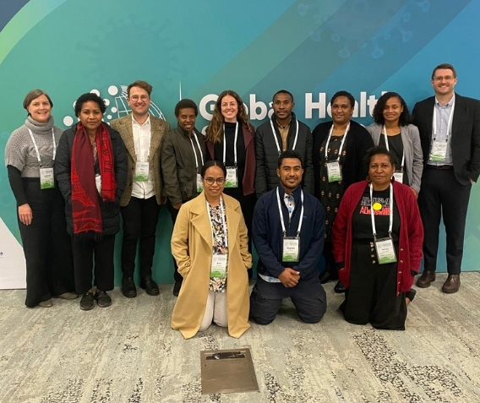
Executive Summary
STRIVE has continued to strengthen vector-borne disease surveillance and implementation research capacity in Papua New Guinea in 2024. The program has supported PNG to expand and improve molecular diagnostic and serological capacity for malaria and arboviruses, strengthen provincial and district vector surveillance and monitoring activities and support health workers across all levels of the health system.
Throughout the past year, STRIVE underwent a shift in its project progression, reducing the implementation of new activities and emphasising strengthening and embedding the activities already in operation into the national and provincial systems and processes. To achieve this, the STRIVE partnership-based approach was harnessed to facilitate close collaboration with eight Provincial Health Authorities (PHAs), supporting them to identify their strategic priorities and align them to the national strategic plans as well as co-developing research activities and timelines.

STRIVE Transition: Phase 1 to Phase 2
In 2024, STRIVE was awarded an additional four years of funding by the Australian Government through the Partnerships for a Healthy Region Initiative. The team took this opportunity to reflect on STRIVE’s achievements to date and revisit STRIVE’s goals, aims, and scope for the next four years. In the next phase of STRIVE, the project will utilise the lessons learned, and foundational strengths developed in PNG to support Vanuatu and Solomon Islands in a priority pilot activity to strengthen VBD surveillance and response, whilst continuing to strengthen and expand upon the existing activities in PNG. This exciting new chapter of STRIVE will provide a platform for further knowledge-sharing and capacity strengthening opportunities in Melanesia and strengthen our collective effort in Malaria and VBD surveillance and control in the region.


Vale Leo Makita
Late Mr. Leo Makita, Program Manager, Malaria and VBD Program, National Department of Health and a Program Director of STRIVE, dedicated over 40 years of his life to Malaria and VBD research in Papua New Guinea. His genuine and passionate commitment to this work will leave a lasting impact on PNG. He will be deeply missed.

STRIVE Overview
The overarching goal of STRIVE is to strengthen PNG, Solomon Island and Vanuatu’s integrated vector-borne disease surveillance and response capacity. This will be achieved through the following end of program outcomes:
- Embedded sustainable capacity and systems for integrated sentinel surveillance
- Consolidated genomic and serological laboratory surveillance capabilities
- Embedded vector surveillance and response capacity within subnational health teams
- Strengthened health systems supports, enabling effective surveillance and use of data for decision making
- Strengthened partnerships and empowered Local researchers, partners, and organisations
- Assess climate change impact on VBDs, health systems and livelihoods
- Increased accessibility and utilisation of GEDSI data to inform national activities and policies
- One health approaches integrated into surveillance and molecular hub diagnostics framework
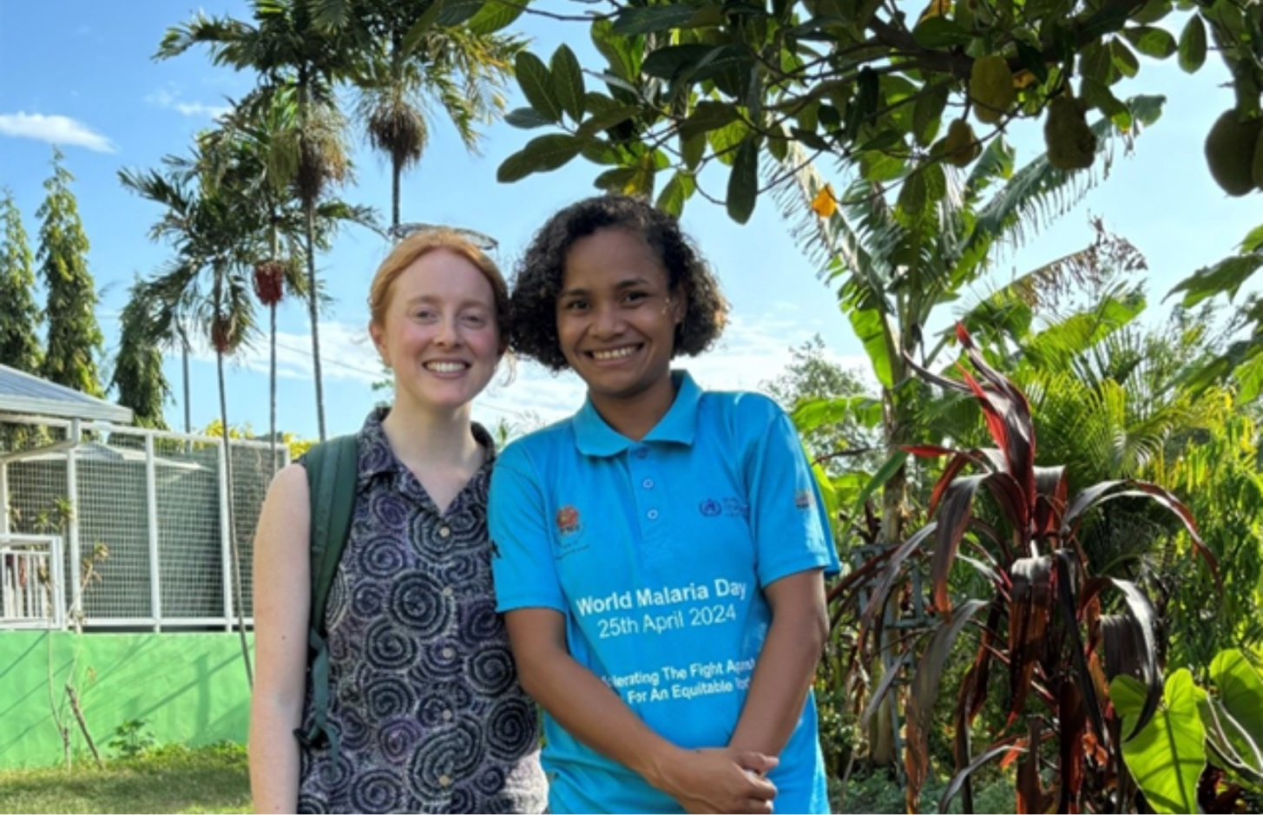

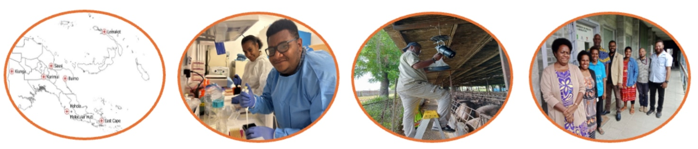
STRIVE Work-Streams

Febrile Illness Surveillance
8 sentinel sites
Febrile illness cases triaged to sentinel site nurse for enrolment, consultation, data and sample collection
Samples sent to:

Molecular
Hub
Strengthen molecular diagnostic and genomics surveillance capacity
Malaria species
Markers of artemisinin resistance
Arboviruses
Multi-pathogen sero-surveillance

Vector
Surveillance
Strengthen provincial vector surveillance capacity
Larval habitat surveillance
Adult mosquito surveillance
Insecticide resistance monitoring

Health System Strengthening
Strengthen health systems supports to enable effective surveillance
mSupply
Health facility assessments
Cost-effectiveness analysis

STRIVE also integrates partnership strengthening, GEDSI, climate resilience and one health approaches in all work-streams as Crosscutting approaches.

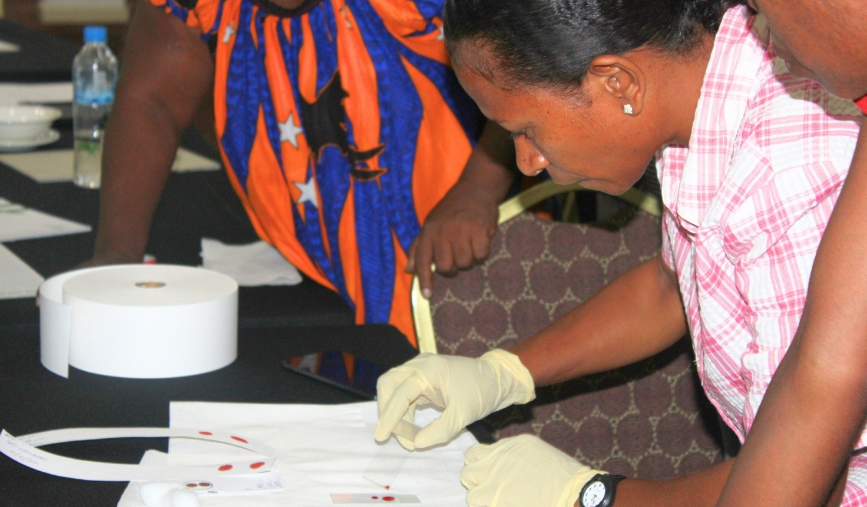

Febrile Illness Surveillance

Overview
In 2024, STRIVE continued to generate data from eight sentinel sites across PNG. In Q4 of 2024, an additional sentinel site at Mugil in Madang Province was incorporated in to the STRIVE network [data to be reported from 2025 onwards] expanding to a total of nine sentinel sites. The team also strengthened and expanded data collection and visualization to support rapid identification and containment of outbreaks, resurgence and resistance.

Key Achievements

Five years of data collection

In 2024, STRIVE marked five years of febrile illness data collection at sentinel sites. Beginning in October 2019 at the Baro Community Health Post, surveillance activities have been implemented at eight sites across the country and over 22,000 cases have been recorded, creating a wealth of data that is being used to guide vector-borne disease strategy, approaches and resourcing in PNG. A snapshot of the data from the last five years is displayed on the next page.

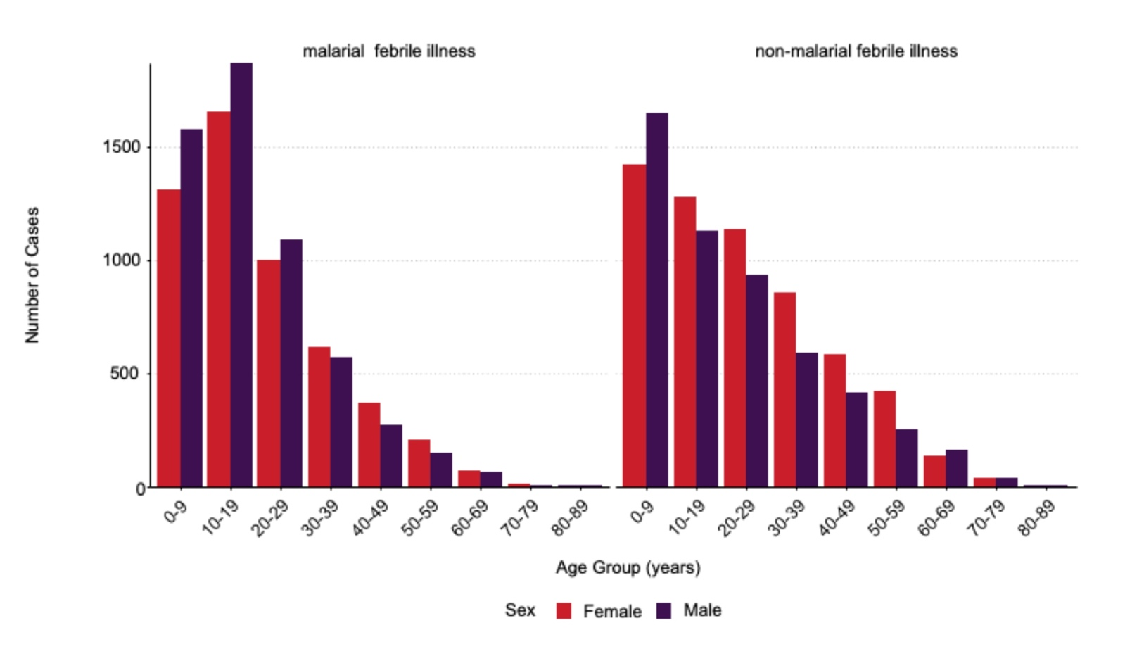
Malaria febrile illness is most common in younger age groups, particularly in children aged 0–9 and 10–19 years.
Males have a slightly higher burden of malaria febrile illness in younger age groups, while the sex distribution for non-malaria febrile illness appears more balanced.

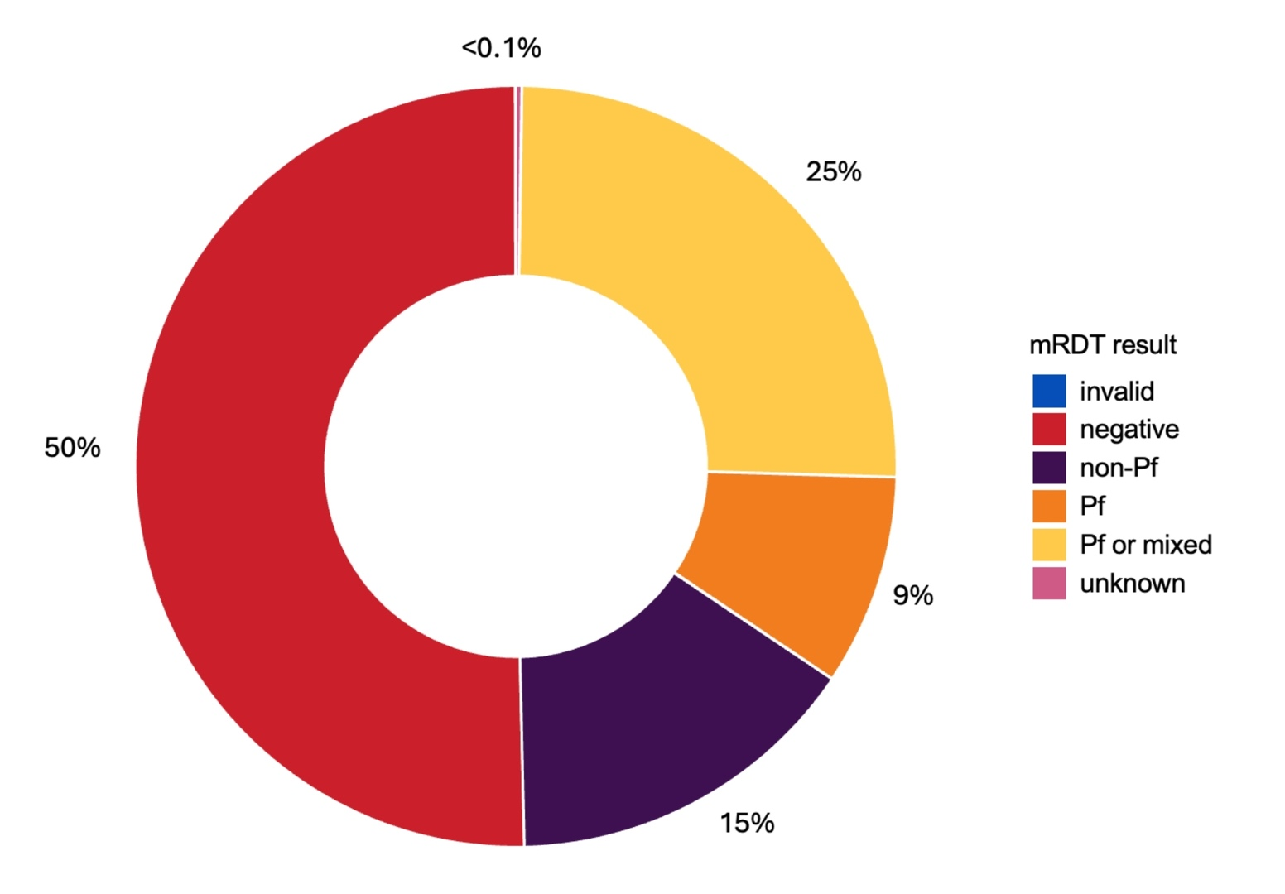
50% of febrile illness presentations are malaria rapid diagnostic test (mRDT) negative (red segment), highlighting the burden of non-malarial febrile illness in PNG.
Overall, there is a predominance of P. falciparum with 34% of febrile cases “Pf” (orange) or “Pf or mixed” (yellow) by mRDT.
15% of febrile cases were classified as “non-Pf” (purple), the majority of which are P. vivax cases (confirmed by molecular testing at the Molecular Hub, see below).
Very few (<0.1%) of RDT results were “invalid” or “unknown” during the five years of surveillance. All “invalid” tests are reported to the NMCP to inform their monitoring of test performance.

GEDSI Dashboard

The STRIVE GEDSI dashboard went live on Tupaia in 2024. The dashboard presents data disaggregated by sex, age, disability, pregnancy status, malaria diagnosis and treatment in all eight sentinel sites. The Washington Short Set of questions have been used to collect data on people living with a disability. This allows users to identify patterns and gaps in outreach, diagnosis and treatment.
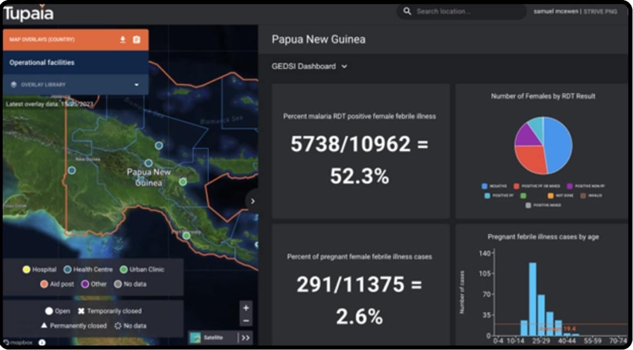


Sentinel Site Training
In June 2024, the STRIVE team conducted a clinical refresher training for 21 sentinel site nurses, project staff, and trainers, focusing on sample collection processes critical to malaria surveillance. Pre- and post-training surveys revealed significant gains in confidence. Female participants, who started with slightly lower confidence levels than their male counterparts, showed the most substantial improvement.
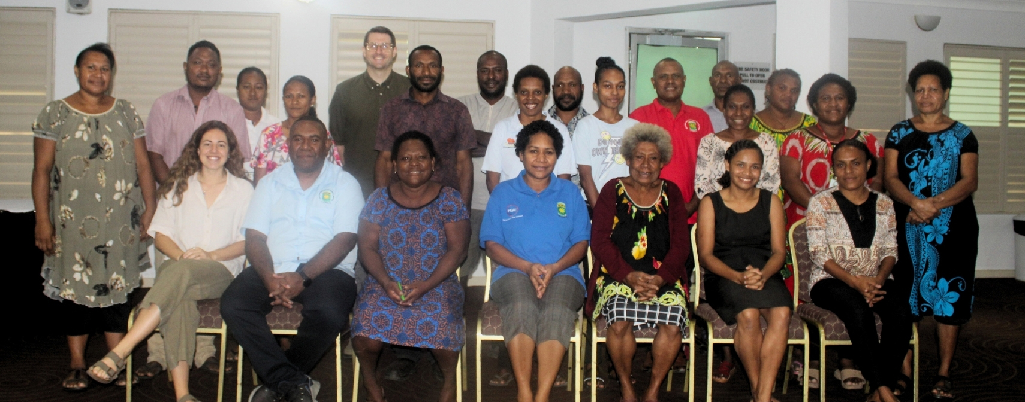
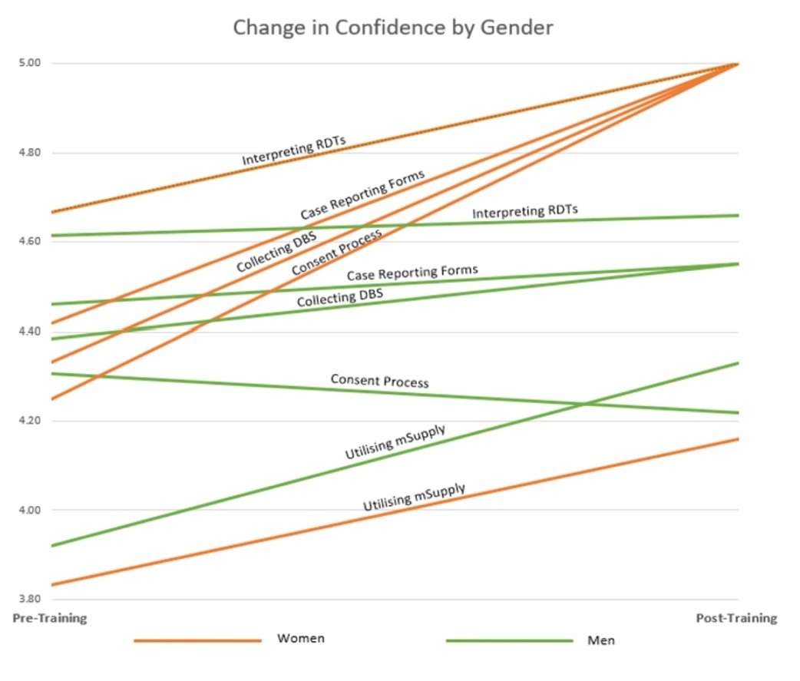
Graph showing improvements in confidence for the sentinel surveillance data collection processes, disaggregated by gender of training participant.

Team Success Story
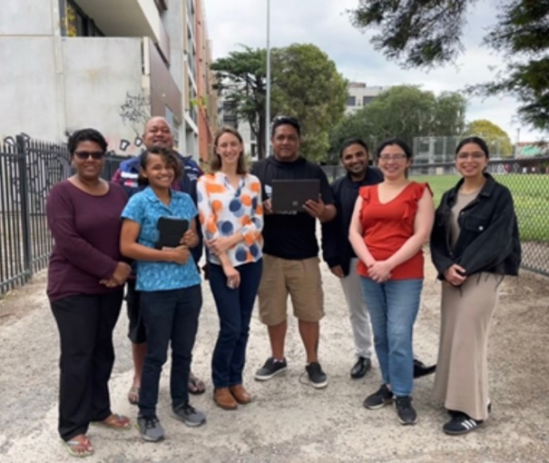
Marie Elliott, PNGIMR Data Officer, attended a week-long Data Bootcamp in Melbourne, organized by Beyond Essential Systems. The training focused on building expertise in SQL, data visualization using Viz Builder, and the Tupaia platform's administrative functionalities, including survey design, tasking, and data security. Through a mix of hands-on and theoretical sessions, Marie developed advanced skills in data management, analysis, and visualization, which are directly applicable to her role in the STRIVE project.

2025 Goals

To implement the new Data Management System plan for the unified, centralised and streamlined management of surveillance data. This will enhance equitable access, reduce reliance on individual team members for dataset ownership, improve data security, and streamline reporting.
To establish an additional sentinel site in the Autonomous Region of Bougainville.

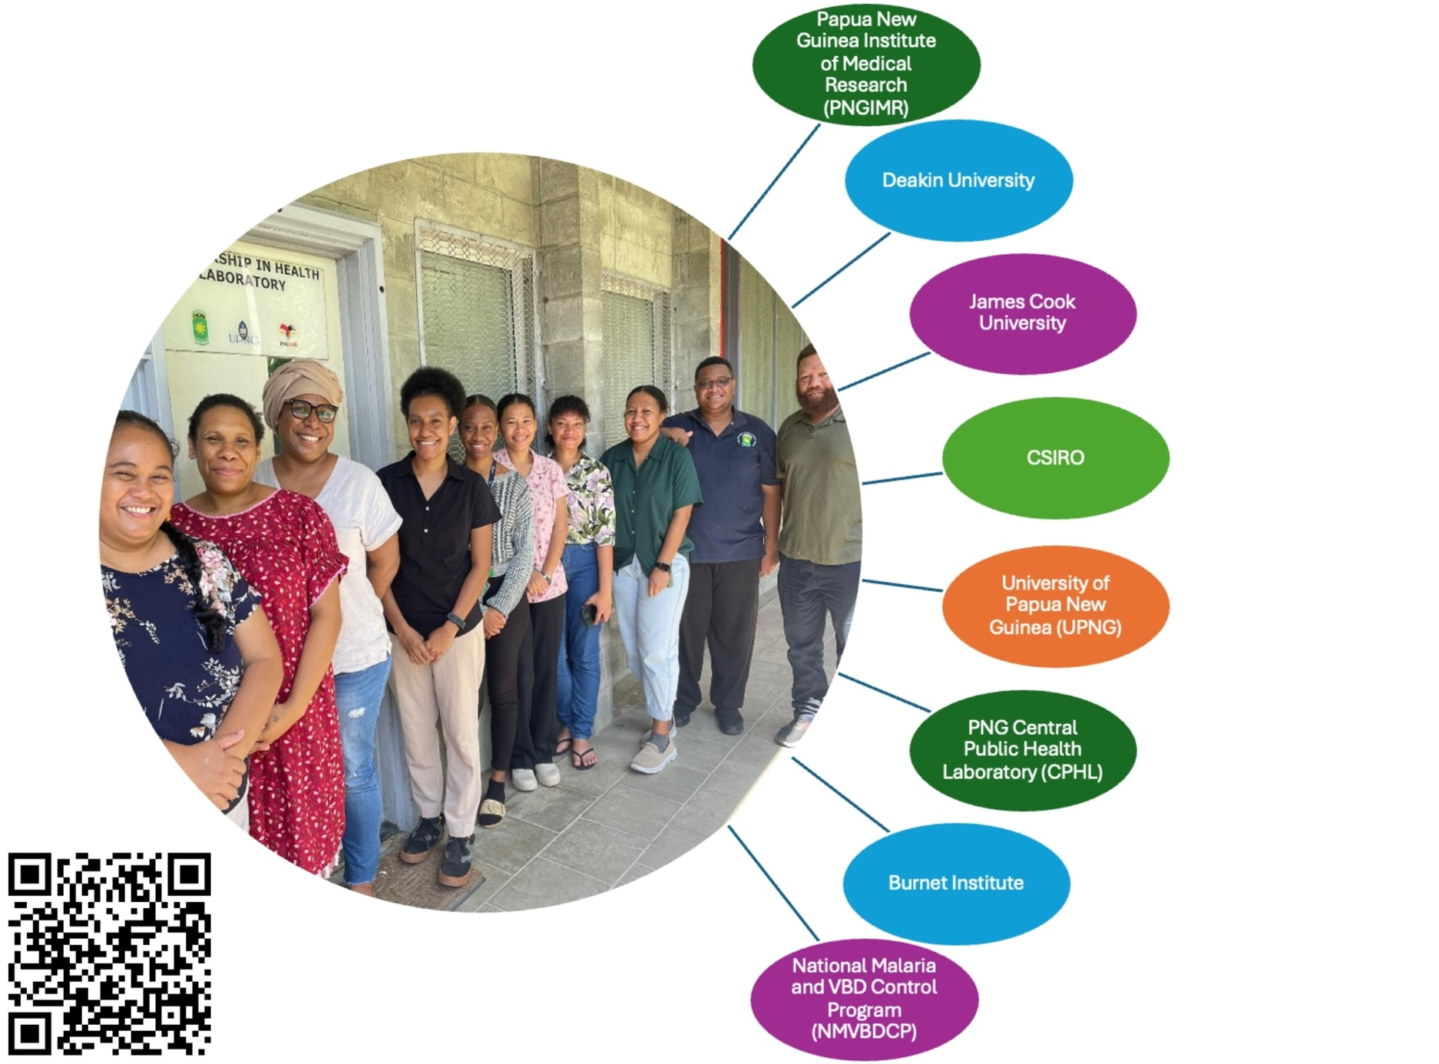
Molecular Hub

For more info on the Molecular Hub, scan the QR code.

Overview
The PNG Molecular Hub is made up of a consortium of local and international collaborators that aim to optimise limited molecular assets and expertise, enhance detection and monitoring of priority pathogens, and to support and strengthen surveillance response systems through mutual knowledge and resource sharing.
Molecular surveillance is becoming increasingly important for detecting emerging arboviral pathogens such as DENV, CHIKV and ZIKV, as well as for detecting anti-malarial drug resistance markers and HRP2/3 deletions in Plasmodium parasites that threaten the viability of currently used drugs and mRDTs. Strong in-country diagnostics capacity facilitates early detection of outbreaks and emerging drug resistance.

Key Achievements

Close to real-time testing
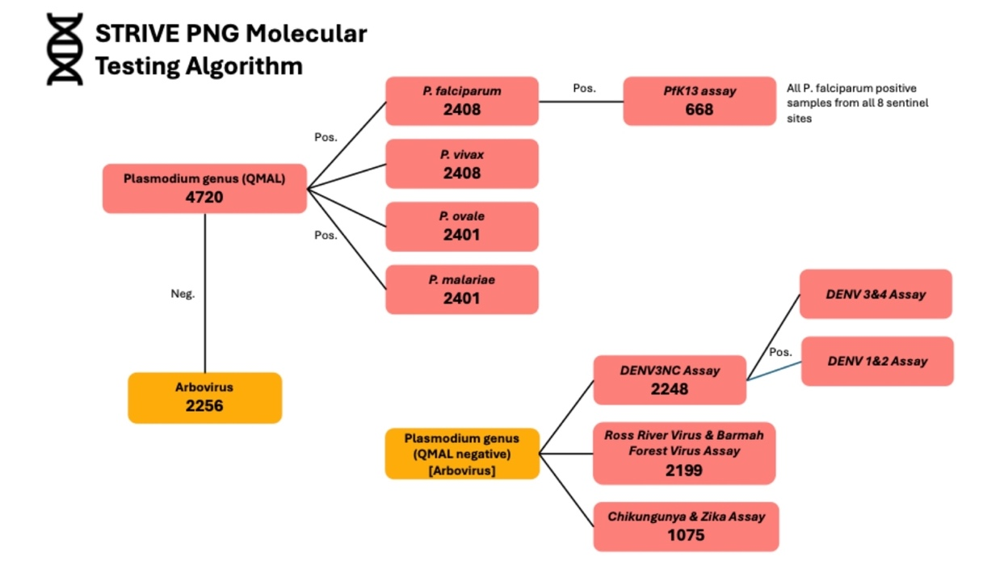
The STRIVE Molecular Hub team completed testing of all back-log samples collected between 2019-2023 and are now conducting close to real-time testing for the detection of malaria and arboviruses, supporting early detection of outbreaks and drug resistance. The testing algorithm followed in 2024, including the number of tests done at each step, is outlined below.
The figure below shows the Pan-species QMAL and species specific malaria positivity rates in all STRIVE febrile illness dried blood spots tested between 2019-2024 stratified by mRDT result. The majority of mRDT positive cases were positive in the QMAL assay. This association was strongest for mRDT Pf or mixed positive cases and mRDT non-Pf positive cases. In mRDT Pf or mixed positive cases, PCR testing revealed 77.5% of cases were positive for P. falciparum with only 9.5% positive for P. vivax and less then 1% positive for P. malaria or P.ovale. In mRDT Pf positive and mRDT non-Pf positive cases, PCR revealed majority to be positive for P. falciparum and P. vivax respectively. Some positivity for P.vivax was obsevred in mRDT Pf positive cases, and likewise some P. falciparum positive cases were observed in mRDT non_Pf cases. 20% of mRDT negative cases were QMAL positive, P.falciparum being identified in 5.6% of mRDT negative cases and P. vivax identified in 3.3% of mRDT negative cases.
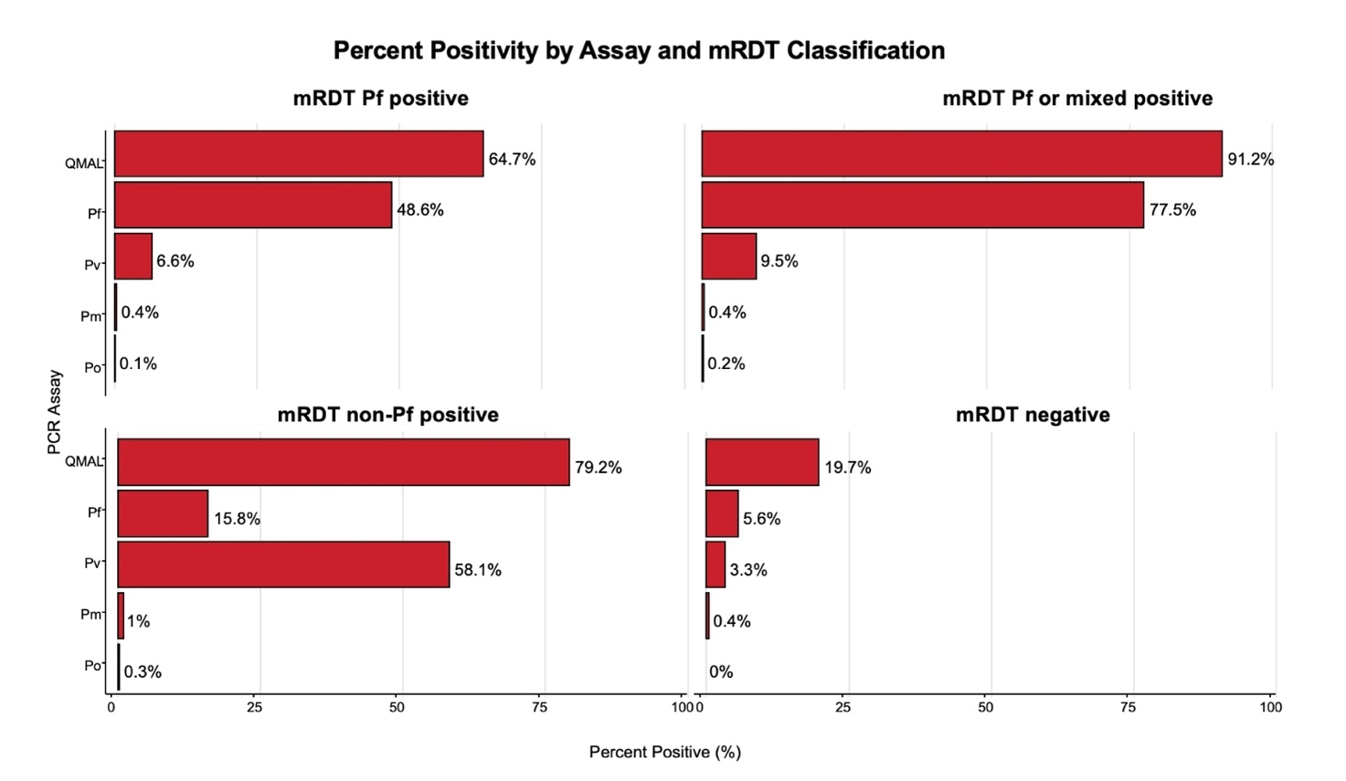
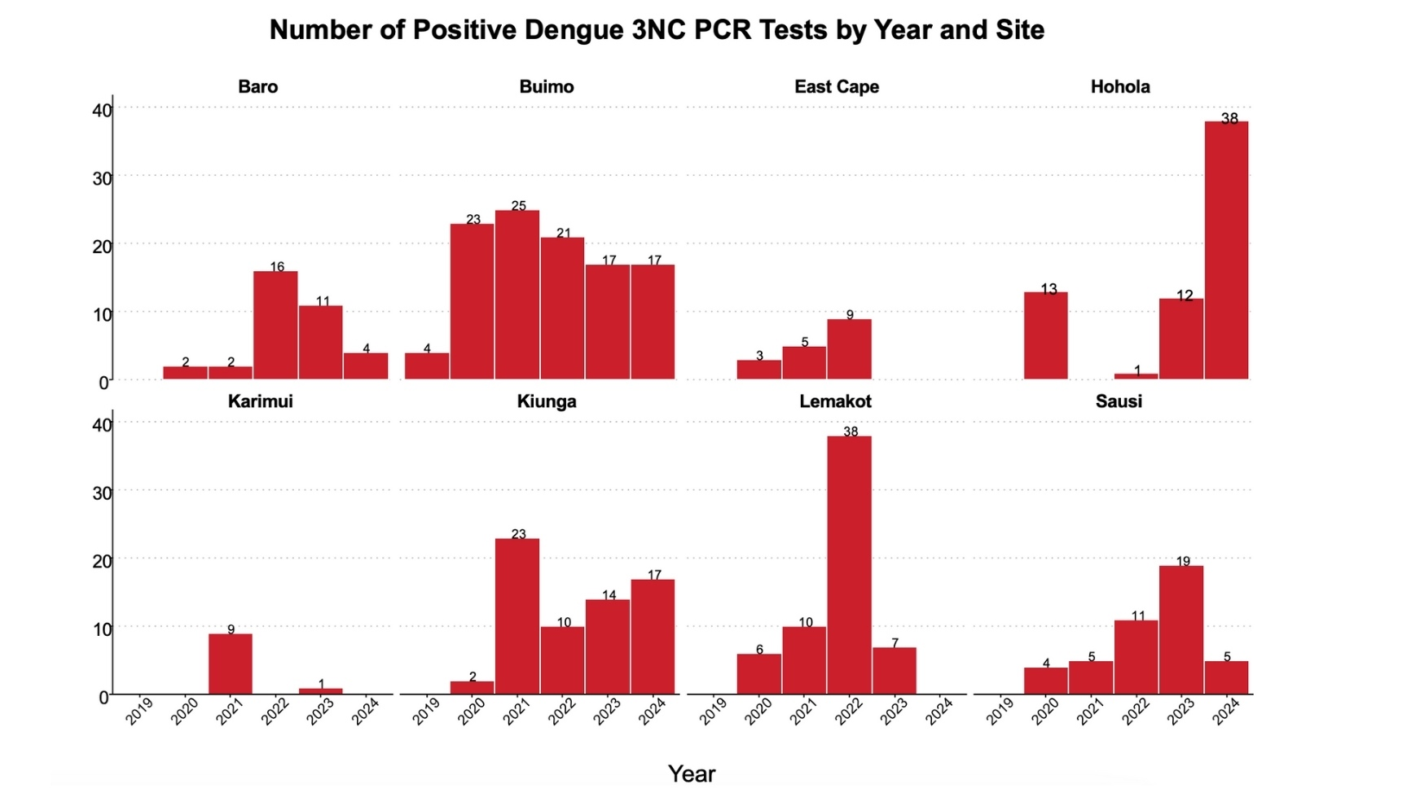
The molecular hub conducts PCR testing for arboviruses, including the generic Dengue 3NC, Ross River Virus (RRV), Barmah Forest Virus (BFV), Chikungunya (CHIKV) and Zika (ZIKV). To date, there has been no detection of RRV, BFV, CHIKV or ZIKV in samples screened at the molecular hub. Dengue has been detected at all sentinel sites, however has been most frequently detected at Kiunga, Buimo, Lemakot and Hohola (see figure below). Over time, detection has indicated signs of variation in Dengue incidence with spikes in the number of cases detected at certain locations in certain years, 2021 in Kiunga (n=23), 2022 in Lemakot (n=38), 2023 in Saudi (n=19) and 2024 in Hohola (n=38). The Buimo site in Lae however has shown fairly consistent detection across all surveillance years. These results highlight regional variability in Dengue incidence which may require targeted public health interventions to mitigate disease transmission specific locations based on local epidemiology.


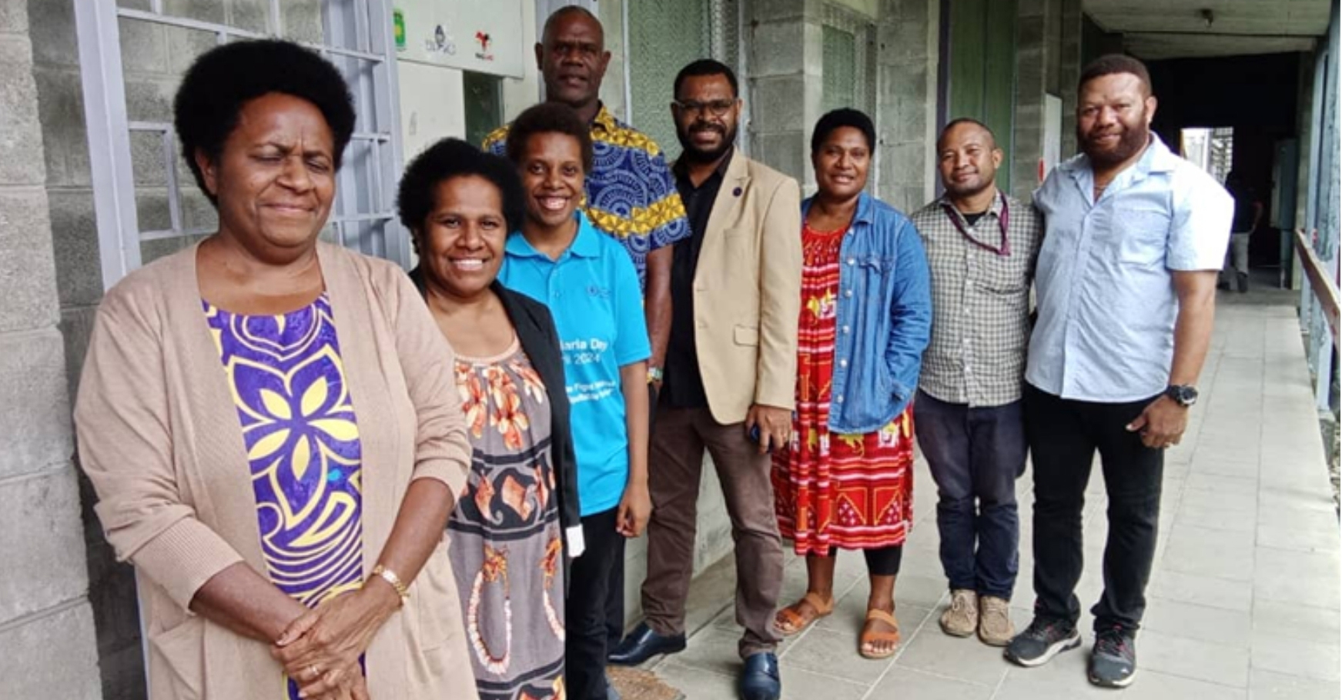
Regional Engagement
The Molecular Hub team are working in partnership with the Vanuatu Ministry of Health to co-design a molecular knowledge and skills exchange program. Co-planning is ongoing with the proposition to commence training of molecular scientists from Port Vila Central Hospital in Q2 of 2025.

Establishment of PfK13 C580Y real-time PCR

The Hub has successfully established the PfK13 C580Y real-time PCR, which detects the Plasmodium falciparum C580Y mutation that has been associated with delayed parasite clearance and artemisinin drug resistance. The identification of this mutation is critical for the early detection of possible artemisinin resistance and to guide the location of therapeutic efficacy studies, which monitor for first-line treatment failure.

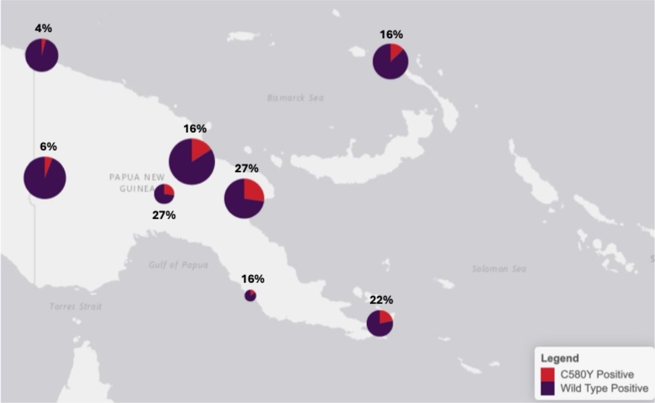

Spatial distribution of P. falciparum K13 C580Y mutations across sentinel sites
Data generated in 2024, has detected K13 C580Y mutations in P. falciparum positive cases at all eight sentinel sites across PNG. This map shows the percentage distribution of positive P. falciparum Kelch 13 by mutation type across the eight sentinel sites. Larger pie charts represent sites with higher sample sizes of positive P. falciparum isolates, while the percentages above each site indicate the proportion of isolates positive for the C580Y mutation. Notably, sites such as Lae and Karimui have a higher prevalence of C580Y (27%), indicating potential hotspots for resistance development. This might also indicate that spread of K13 C580Y mutation might be facilitated by transit networks and population movement which is common between the Highlands and Morobe. Future genome sequencing and analysis may be able to provide clearer evidence to inform understanding of transmission dynamics.
Conversely, sites like Baro (4%) and Kiunga (16%) show much lower prevalence of C580Y reflecting regional variability in the occurrence of this mutation. Interestingly, as these are both border locations the lower prevalence may indicate that C580Y importation is not being primarily driven by land-border routes. These data are critical for monitoring antimalarial drug resistance and guiding targeted intervention strategies and can help inform the NMCP how to target their Therapeutic Efficacy Studies.

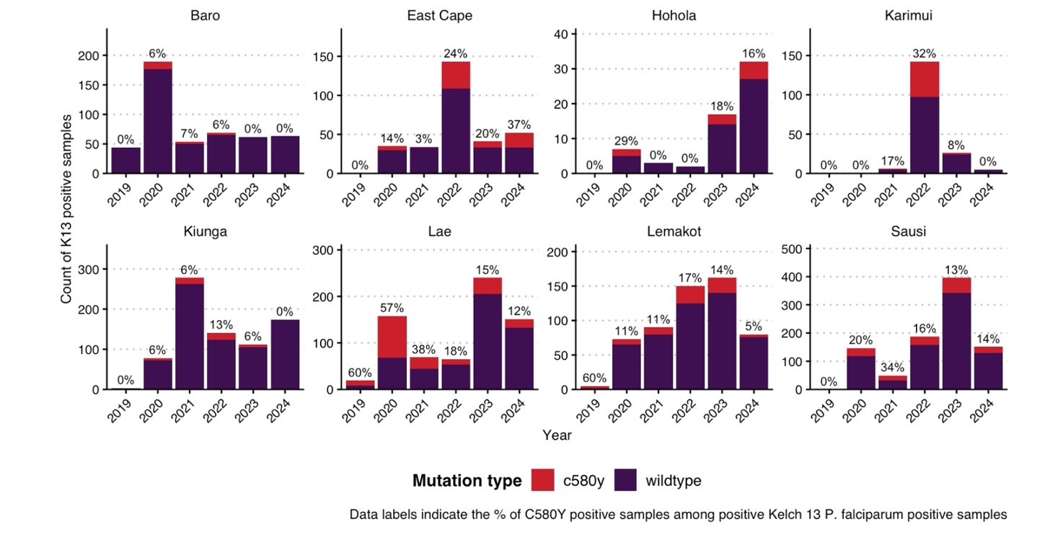
Number of positive K13 samples by mutation type, by sentinel site and year, 2019-2024
The prevalence of C580Y mutations in samples positive for Kelch 13 mutations varies across sites and years, with notable peaks in East Cape (24% in 2022 and 37% in 2024), Karimui (32% in 2022) and Lae (57% in 2020). In contrast, sites like Baro, Kiunga and Sausi show consistently lower proportions of C580Y mutations, with some years exhibiting no detectable C580Y. The trends highlight there is likely regional and temporal variation in mutation prevalence, emphasizing the importance of targeted surveillance to monitor potential resistance hotspots and inform malaria control efforts.

Team Success Story

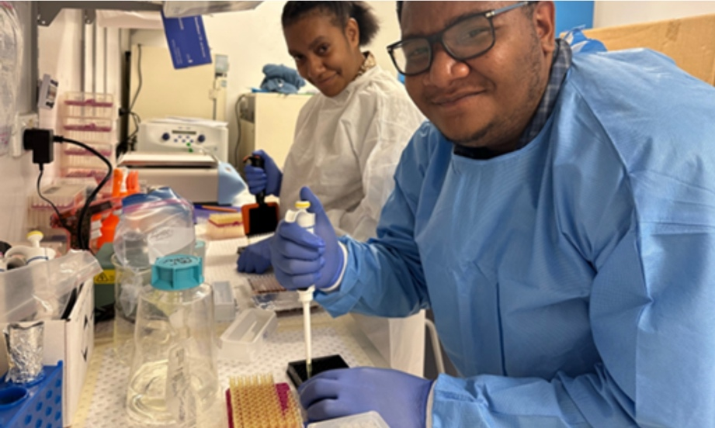
“In 2024, we altered our molecular testing workflows at the Hub, restructuring responsibilities such that each molecular officer is responsible for running one or two specific PCR assays. This change allowed individual officers to take full ownership of their designated tasks and also empowered staff by demonstrating trust from senior officers to work independently and excel in their specialized roles. With the autonomy to manage their specific PCR workflows, the laboratory significantly improved overall testing efficiency and staff professional development.”
- Rebecca Narokobi, Senior Molecular Scientist

2025 Goals
To establish the Pfhrp2/3 real time PCR to detect parasites with deletions in the Pfhrp2/3 genes. These genetic mutations prevent the production of Pfhrp2/3 proteins which is the antigen targeted in malaria RDTs used in PNG, ultimately causing false negative results.
To strengthen regional engagement in Vanuatu and Solomon Islands through molecular skills sharing.
To integrate multi-pathogen serology testing for Sentinel Sites samples. Seroprevalence data helps illustrate exposure patterns and disease transmission dynamics.
To continue working with NAQIA and NDOH to detect JEV among reservoir species and close-contact workers. This supports One Health as JEV is a zoonotic disease spread
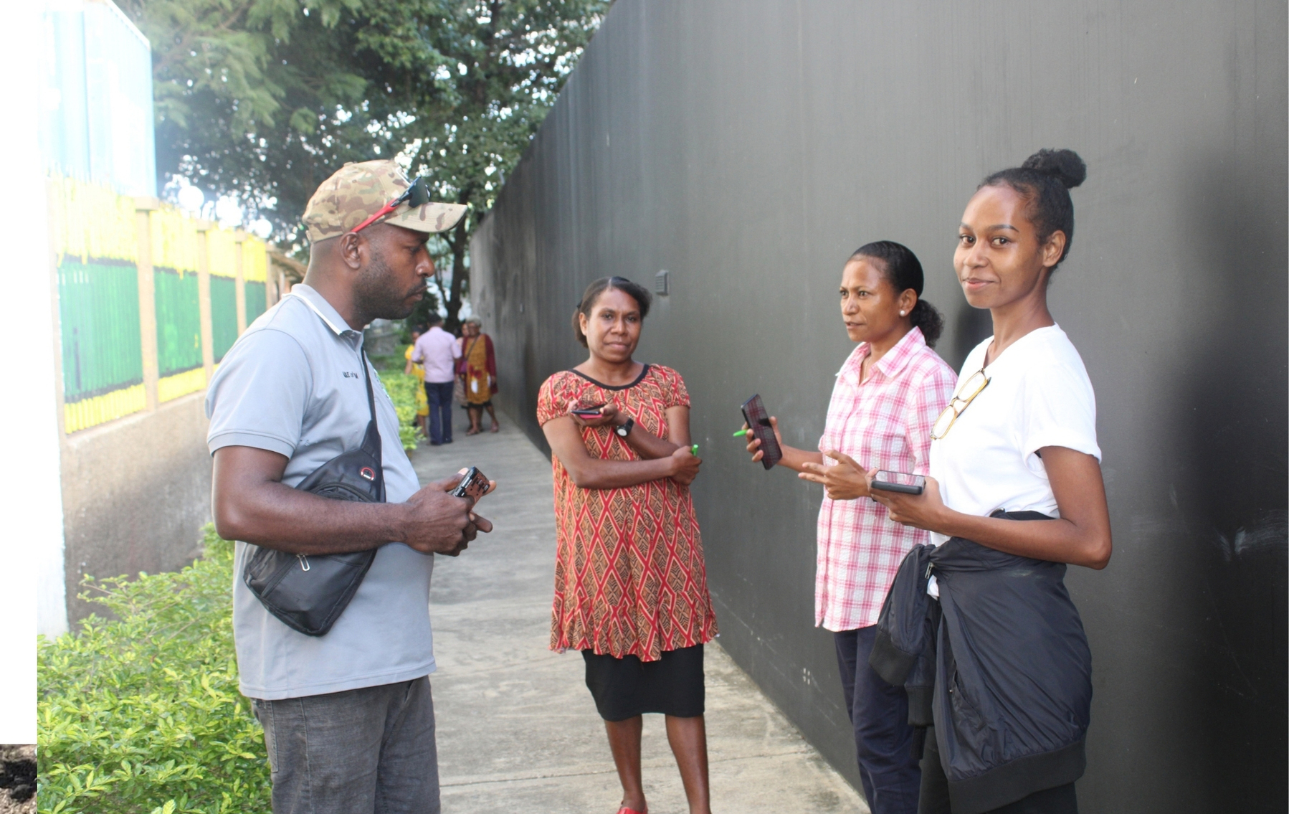

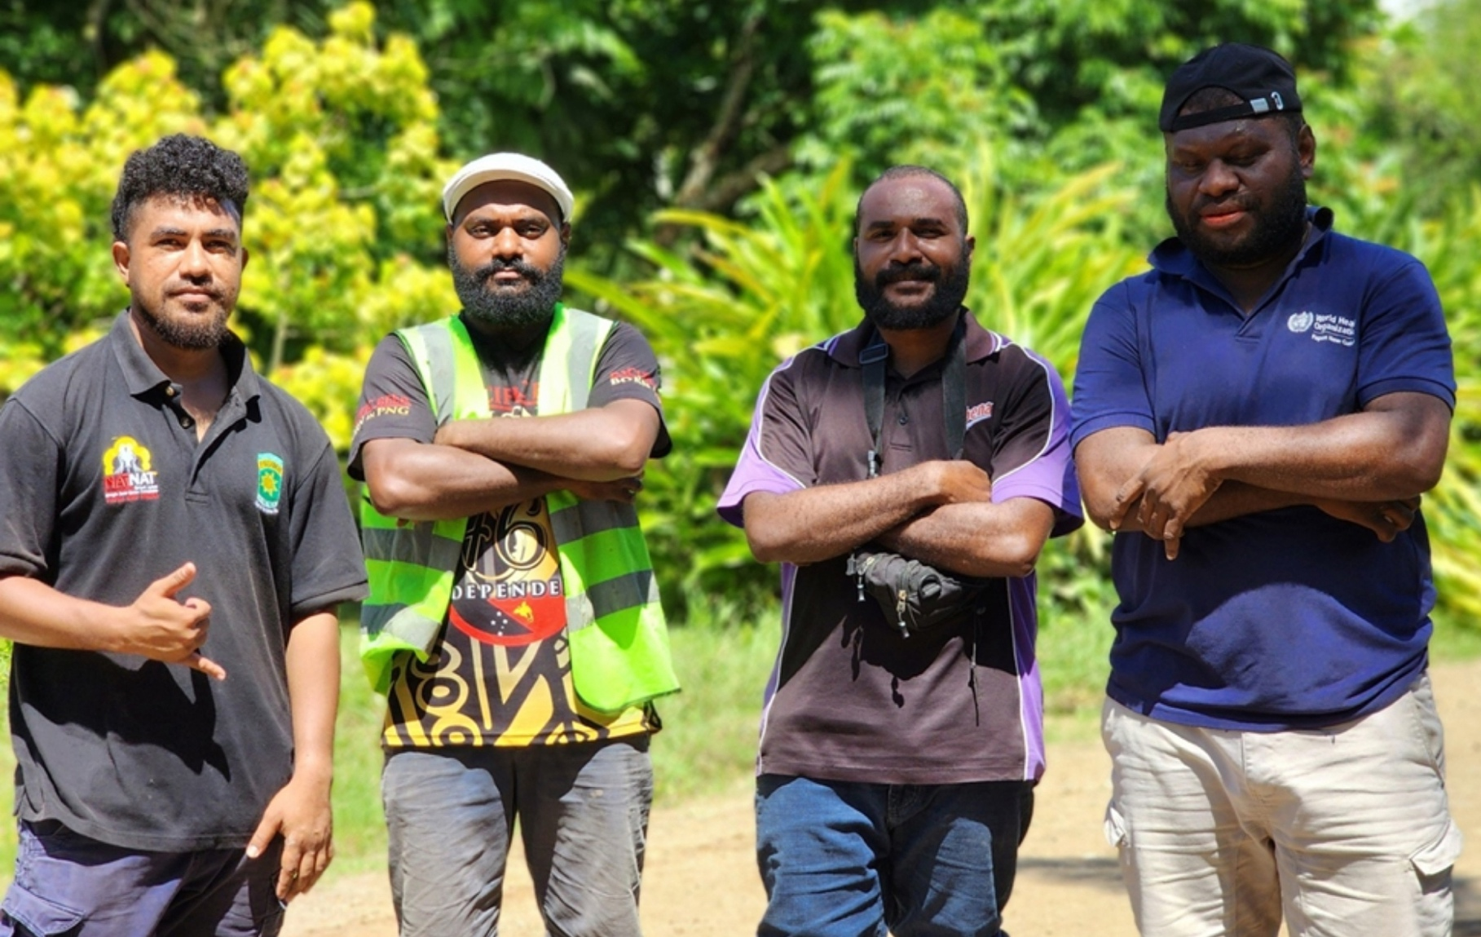
Vector Surveillance

Overview
Collecting information about vectors, the living organisms that transmit pathogens, supports decision-makers to implement the most effective strategies against vector-borne disease. The STRIVE vector surveillance team collaborates with Global Fund and NDoH to conduct Insecticide Resistance Monitoring (IRM) on mosquitoes which transmit malaria and arboviruses. Common arboviruses include dengue fever, chikungunya, and Japanese encephalitis.

Key Achievements

Insecticide Resistance Monitoring (IRM):
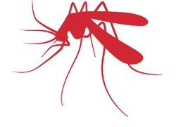
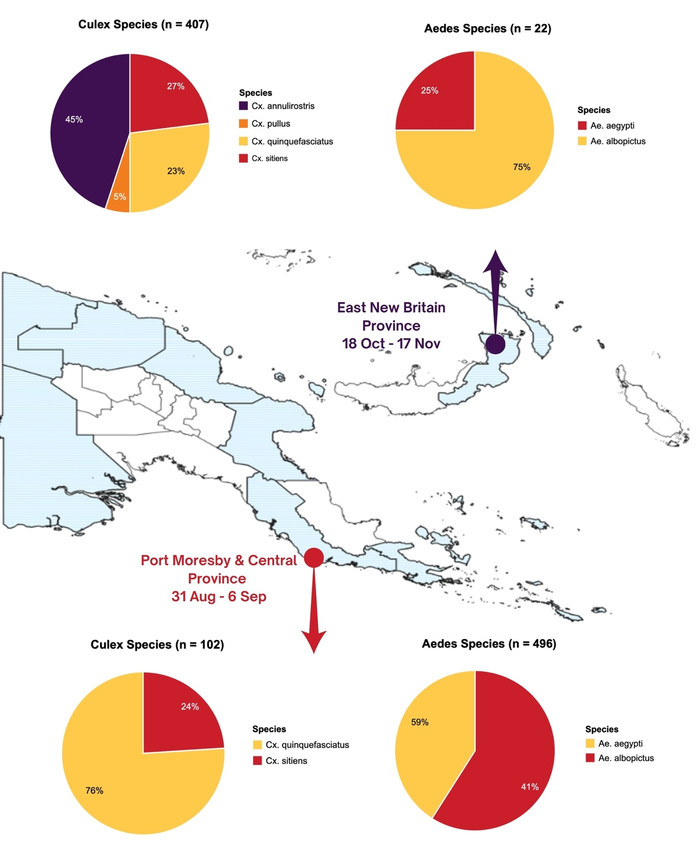
The vector surveillance team, in collaboration with the Global Fund, conducted IRM for Anopheles and Aedes mosquitoes and piloted IRM for Culex mosquitoes in Port Moresby, Central, and East New Britain. This built upon existing efforts to monitor insecticide resistance, which is crucial for guiding vector control strategies.

2024 Insecticide Resistance Monitoring Results
Results from the 2024 IRM activities in Central Province, National Capital District, and East New Britain showed that the three main malaria vectors are susceptible to all seven insecticides that were tested. However, the two arbovirus vectors, Ae. albopictus and Ae. aegypti, were resistant to all five insecticides tested, except for 5% Malathion. This data indicate that Anopheles species in PNG are fully pyrethroid susceptible and pyrethroid-based interventions are fully effective against these populations. This includes first-generation ITNs against malaria as currently implemented. Vector control targeting Aedes needs to include non-pyrethroid alternatives, which may be relevant for urban centres such as Port Moresby, and Lae, and also important for workforce protection programs implemented in the private sector More data is needed to assess phenotypic insecticide status of public health-relevant Culex species, as not enough specimen were tested in 2024.

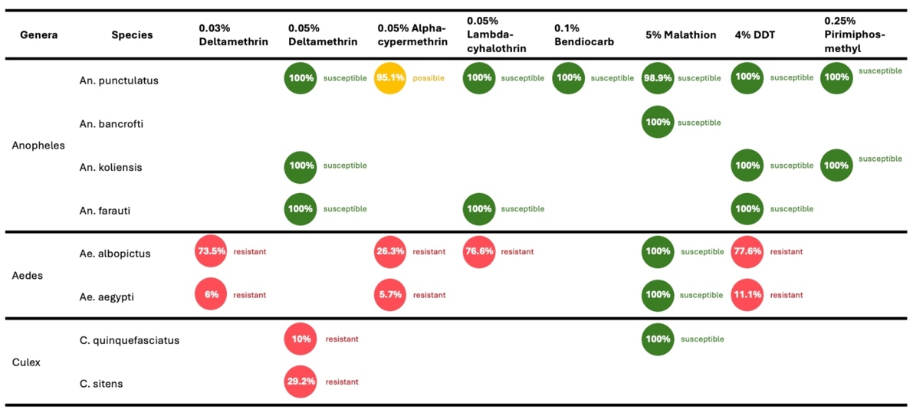
Central and National Capital District

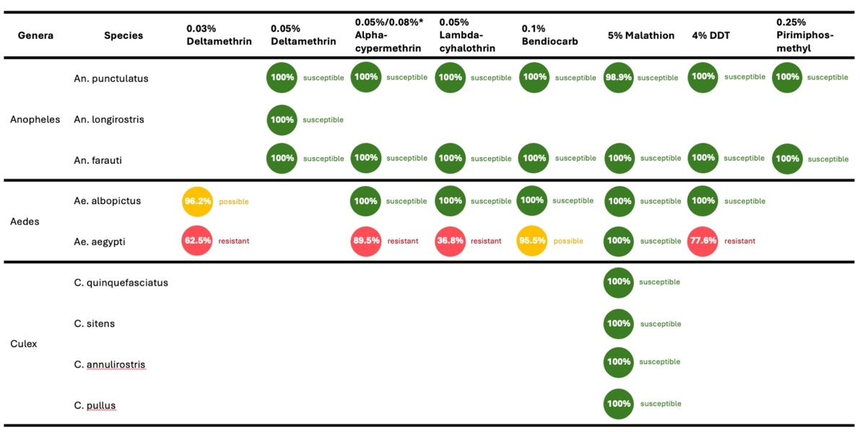
East New Britain

Longitudinal Larval Habitat Surveillance (LLHS) Pilot in Kiunga
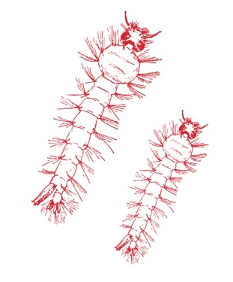
The Kiunga vector surveillance team established a pilot of LLHS, which routinely surveys and identifies mosquito larvae habitats in selected areas. In 2024, all 12 rounds of LLHS were completed and the team developed and shared reports with local health authorities. Outcomes include strengthened documentation of processes, increased consistency of reporting and the development of a ‘LLHS Package’; a collection of documentation which supports routine LLHS Kiunga, and supports design and implementation for new Provincial or District teams who seek to undertake larval habitat surveillance in different locations.

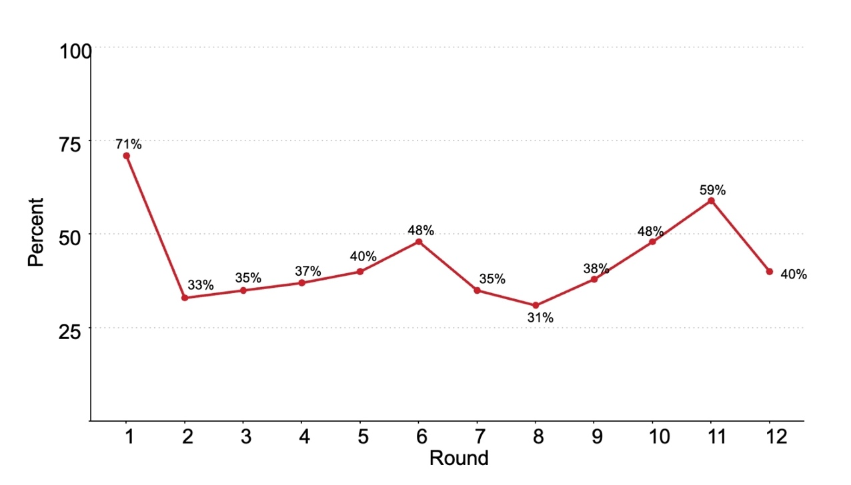
Percent of habitats positive by LLHS, all collection sites, Kiunga, 2024
The percent of positive habitats detected fluctuates over the rounds, with a significant decline from Round 1 (71%) to Round 2 (33%), followed by relatively stable levels around 35–40% until a peak in Round 11 (59%).
The temporal variability in larval abundance and detection of notable spikes in Rounds 6 and 11 can help inform public health decision making.


Longitudinal Larval Habitat Surveillance Training
The Vector team conducted LLHS training in Port Moresby in September-October 2024. The training strengthened capacity to conduct routine surveillance as well as formed valuable connections across provinces and sectors in Papua New Guinea and the broader Melanesian region.

Team Success Story
In September – October 2024 the STRIVE Vector team held LLHS Training, taking a ‘learn by doing’ approach whereby participants received Vector and LLHS theory and tools, before applying these in practical data collection, analysis and reporting activities. Participants consisted of
Ok Tedi Mining Limited (OTML) Staff (3 officers: Mrs Miriam Yambie, Mr Jimmy Simon and Mr Jackson)
Milne Bay PHA Vector Officer (Mr Clyde Toboeta)
West Sepik Health Surveillance Officer (Mr Francis Saimor)
Entomologist from Ministry of Health in Vanuatu (Ms Christie Makikon)
VBDCP Program Coordinator Honiara City Council in Solomon Islands (Mr George Fafale)
This led to significant increases in confidence among attendees on LHSS activities, as well as strengthened relationships and collaboration between organisations working in vector surveillance in PNG and across Melanesia.
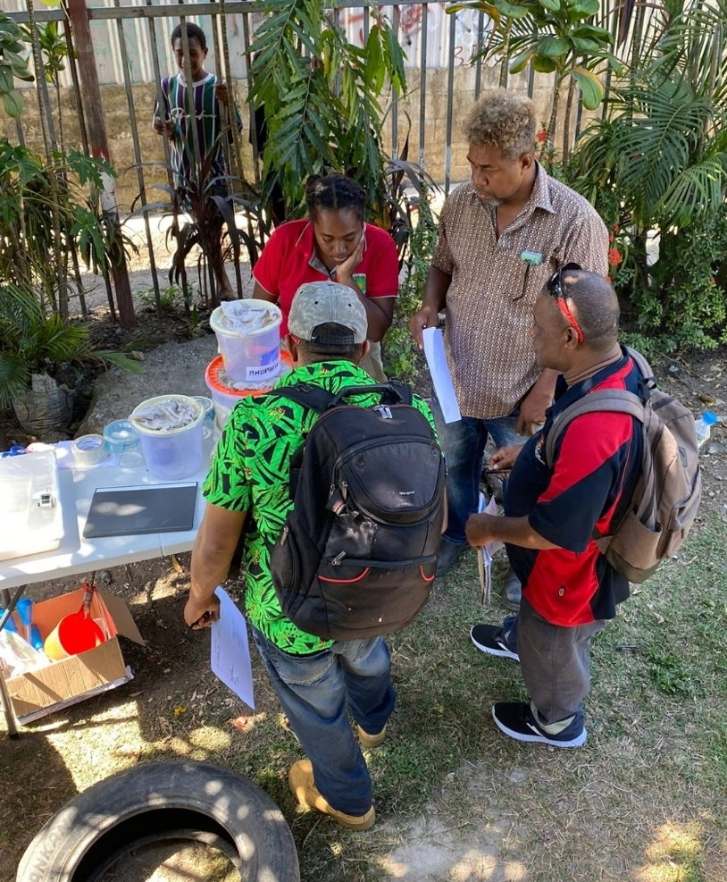

“I've learnt new things to take on and implement. Also, thumbs up to the facilitators for their great support and effort into this enjoyable workshop. Their presentation and explanation were crystal clear. I believe there is more room for learning and improvement in vector control and such Workshop like this is a great platform to start with.”
- Anonymous Participant

“A very good training for all. Needs more of this training especially on how to conduct survey questions to collect the right data. Working together in Partnership is encouraged.”
- Anonymous Participant

2025 Goals
Scale up LLHS implementation to cover 3–4 provinces, including West Sepik Province, Milne Bay, and the National Capital District (Port Moresby).
Initiate a pilot program for adult mosquito surveillance in Port Moresby, employing advanced tools such as whole mosquito traps, to obtain critical data on adult mosquito populations, which are essential for evaluating the efficacy of vector control measures and understanding disease transmission dynamics.
Conduct a feasibility study on implementing port surveillance programs in 1–3 provinces. These initiatives will monitor and manage vector populations at critical entry points, such as seaports and airports, to prevent the spread of vector-borne diseases through travel and trade routes. Feasibility studies will assess logistical requirements, resource availability, and potential integration with existing vector control frameworks.

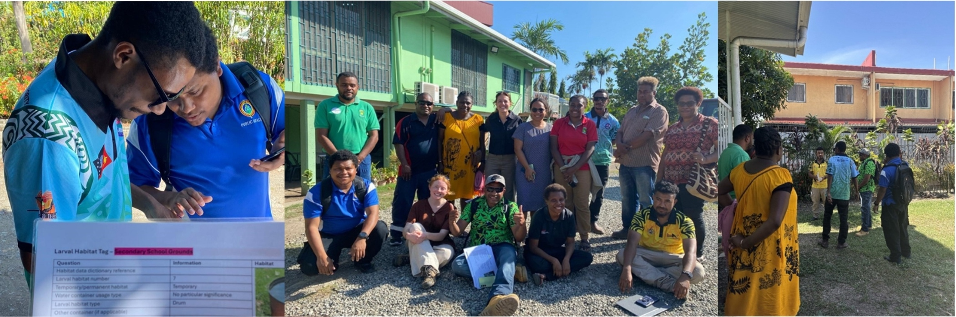

Health Systems Strengthening

Overview
In 2024, the Health Systems Strengthening (HSS) team focussed on supporting policy change and supply chain management to strengthen the capacity of the PNG health system to prevent and respond to vector-borne disease.

Key Achievements


Health Services Assessment
The HSS team finalised a Health Services Assessment Report focused on strengthening VBD surveillance and response through evidence-based policy recommendations.
The report found that service delivery barriers include geographical remoteness, stockouts, and dated treatment guidelines, while enablers include the adaptability of healthcare workers, triage systems, and health promotion initiatives. Key recommendations to strengthen the health system included:
Investing in human resources
Expanding the Community Malaria Volunteer role
Ensuring sustainable financing
Enhancing training and reporting systems


PHA Research Capacity Strengthening Package
The partnership between the West Sepik Public Health Authority (WSPHA) and the STRIVE Project has sought to address the challenge of uncoordinated health NGOs in West Sepik Province. The collaboration led to the development of the PHA Research Capacity Strengthening Package, consisting of key tools to enhance research capacity and coordination.


Improved Stock Oversight and Forecasting
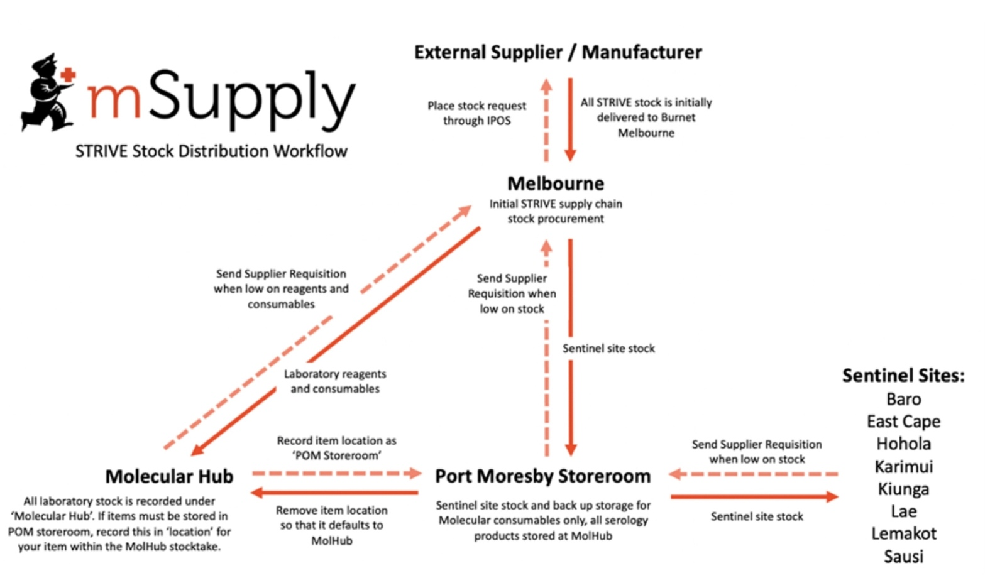
The full integration of mSupply in 2024 has streamlined stock management and allows for real-time tracking of stock movement, facilitating better distribution of medical supplies. STRIVE’s successful implementation of mSupply in the lab setting has become a model for other laboratory sites in PNG.

2025 Goals
To conduct a climate case study to explore the perceptions and knowledge that community members and health system staff have regarding the impact of climate change on health, VBDs, and health systems in Papua New Guinea.
To collaborate with Beyond Essential Systems to visualise malaria commodities, including rapid diagnostic tests (RDTs) and anti-malarial drugs, on the Tupaia platform. This will strengthen stock visibility and integrate medical supply data with surveillance data, to enhance data availability for decision-making and more efficient resource allocation.

Partnerships

Overview
The Partnership Management Unit (PMU) lead the partnership components of STRIVE, forging and brokering partnerships with local, provincial and national health authorities, coordinating collaboration between the diverse organisations within the STRIVE team, and engaging with external organisations, including other internationally funded malaria programs.

Key Achievements

Solomon Islands and Vanuatu Engagement

Through scoping visits, in-country consultations and regular check in calls, the STRIVE project team established partnerships with teams in Vanuatu and Solomon Islands, and worked together to plan activities that were feasible, aligned with national priorities and built for sustainability. The visits established a framework for continued cross-learning and support between countries in the region, promoting knowledge exchange and joint problem-solving around shared priorities.

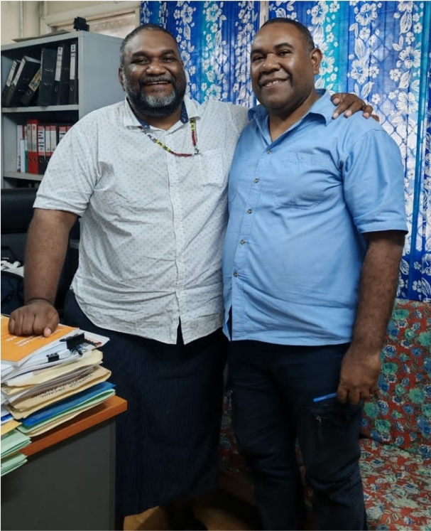
Prof Moses Laman (right), Deputy Director at PNGIMR, with Dr. Neima Bainavalu, Medical Director at the SI Ministry of Health and Medical Services (left) during the Solomon Islands Scoping Visit.


Annie Dori (right), STRIVE Partnerships Manager, with SI NMCP Officer (left) at the Vanuatu Partnership Inception Workshop.

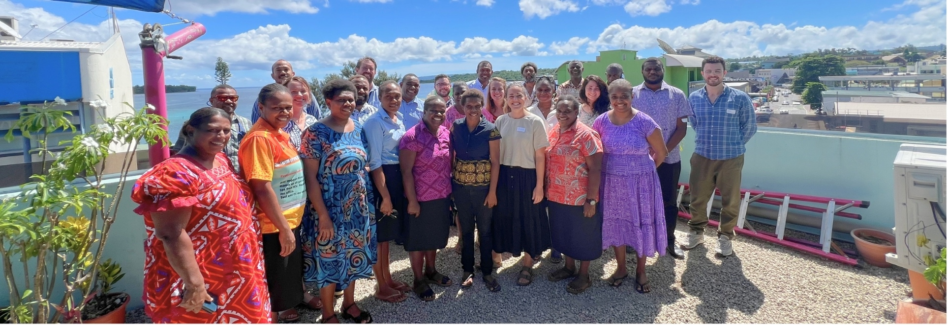
Vanuatu Health Research Partnership Inception Workshop
In April, STRIVE supported the facilitation of a partnership inception workshop in Port Vila, Vanuatu to explore a partnership-based approach to collaborative health research and program implementation in Vanuatu. The workshop brought together over 25 public health officers, policy makers, clinicians, and technical officers (pictured above). The workshop successfully harnessed the enthusiasm for health research of the participants, and the potential for a partnership approach to ensure that research collaborations are effective, equitable and ethically and are aligned with the Vanuatu Health Sector Strategy 2021-2030. Outcomes of the workshop include broad support for a partnership approach for future engagement on health research, identified need for a health research institute, need for health research training, and several priority research questions identified.


Provincial Health Authority Support
STRIVE conducted focused discussions and regular check-ins with PHAs to plan for embedding various STRIVE components at the provincial level and strengthen local capacity in vector control and integrated disease surveillance.

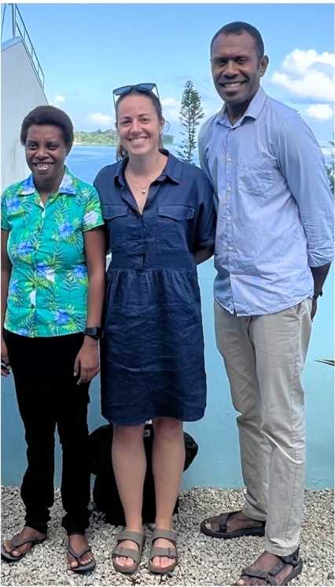

Workshop Facilitators: Annie Dori (left), STRIVE Partnerships Manager, Alexa Murry (center), STRIVE Program Manager, and Kali Ameara (right), Vanuatu Research Coordinator.



Partnership Management Uni

Strengthening Collaboration
STRIVE strengthened ties with other programs resulting in leveraging of resources and coordinated approaches. Several of the collaboration opportunities are outlined below.
Bill and Melinda Gates Foundation: Gates Grand Challenges Malaria Genomic Surveillance
UNITAID VivAction Consortium (SCOPE/ PAVE Study)
APMEN Vivax Readiness Planning
Global Fund
Australian Centre for Research Excellence in Malaria (ACREME)
ARIA RISE
ZAPPA
Indo Pac Lab
Beyond Essential Systems
Trilateral Malaria Project
PacMossi

Team Success Story


“Through close collaboration with Provincial Partners and the National Department of Health (NDoH), particularly the National Malaria and Vector Borne Control Program, we successfully showcased the STRIVE program at the Papua New Guinea Institute of Medical Research Virtual Symposium. Given the opportunity to lead, the spotlight on the project highlighted the program's innovative approaches on contextualizing malaria control and vector-borne disease programs under the leadership of government entities. This collaboration not only strengthened national and provincial partnerships but also highlighted how striking the balance between research and implementation is vital for research, strategies, implementation and outcomes.”
- Annie Dori, Partnership Management Unit

2025 Goals
To conduct a partnership health check for STRIVE, engaging both internal team members and external partners.
To strengthen partnerships between PNG, Vanuatu, and Solomon Islands.

Gender Equity, Disability

Equity and Social Inclusion

(GEDSI)

Overview

The project is informed by a commitment to Gender Equality, Disability and Social Inclusion (GEDSI). A key crosscutting goal is to strengthen GEDSI considerations and activities throughout program outcomes to maximise sustainable change. In 2024, the team planned for operationalising GEDSI across project teams and activities.

Key Achievements


Completed a GEDSI Analysis, Strategy, and Action Plan
These key documents detail the goals, strategies, targets and activities that will drive GEDSI in 2025-2028.

Ensured Gender Representation
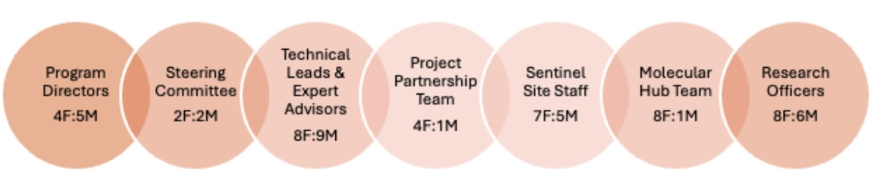
There are 41 women and 29 men involved in STRIVE, with gender balance in senior leadership.

2025 Goals
To operationalise the STRIVE GEDSI Strategy and Action Plan.
To keeping STRIVING towards equity.

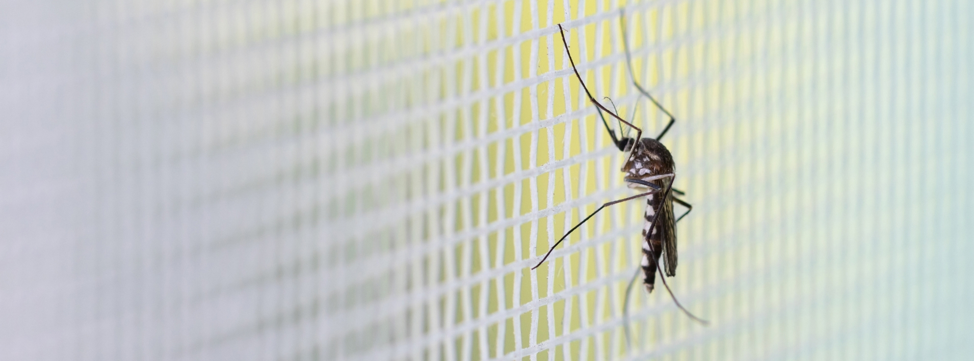
Climate & One Health

Climate
Many vectors, particularly mosquitos are affected by climate factors and that climate change is
expected to alter the frequency of diseases that this project is focusing on: malaria, dengue, chikungunya, zika, Barmah Forest and Ross River. The STRIVE goal to strengthen VBD surveillance and outbreak response capacity is, therefore, contributing to a broader goal of strengthening climate and disaster responsiveness in PNG. Throughout the phase 2 planning that occurred in 2023/2024, partners emphasised a strong desire to understand the impact of climate change by integrating climate modelling into the surveillance platform and climate case studies into our participatory community-based work.

2025 Goals
Conduct a climate case study using ethnographic research methods to explore the impacts of climate on health, health systems, communities and livelihoods Integrate weather and/or climate data at sentinel sites into Tupaia.

One Health
Over the past four years, STRIVE’s partners from both Australia and Papua New Guinea have worked closely to ensure that a one health approach to strengthen vector borne disease surveillance is incorporated into the programmatic planning and delivery of activities. The team continued to work closely with NAQIA and the ZAPPA project (DFAT ACIAR supported) to incorporate and ensure opportunities for integrated animal, vector and human surveillance across rural, urban and farm settings. This included collaborative work to optimise the use of mosquito traps for zoonotic arboviruses and the Molecular Hub team trained Bridgit Kavana from NAQIA (ZAPPA Project) in PCR which has supported the implementation of the PCR African Swine Flu assay. It is acknowledged that partnering with these key organisations and projects contributes towards a greater portfolio of one-health activities; e.g. African Swine Flu monitoring and Antimicrobial Resistance.

2025 Goals
Establish additional arbovirus assays at the Molecular Hub; Japanese Encaphalitis, Murray Valley Encephalitis.
Integrate animal health surveillance at a STRIVE sentinel site.
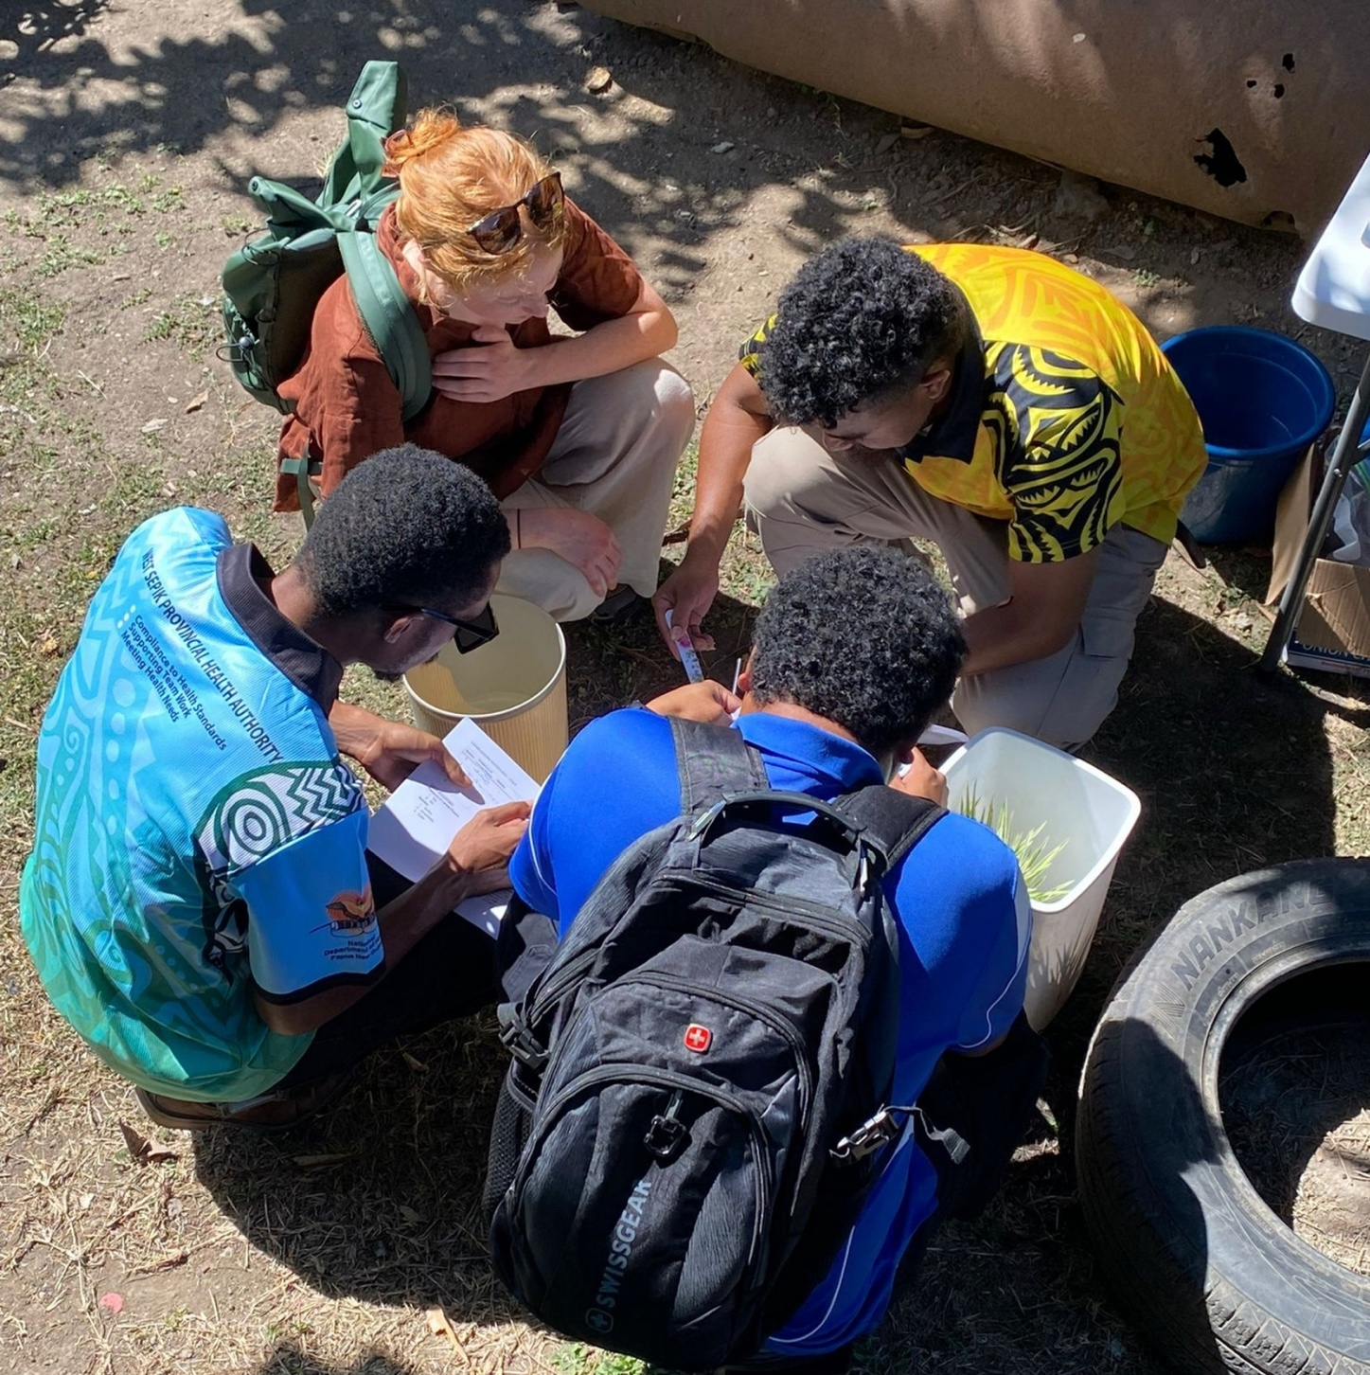

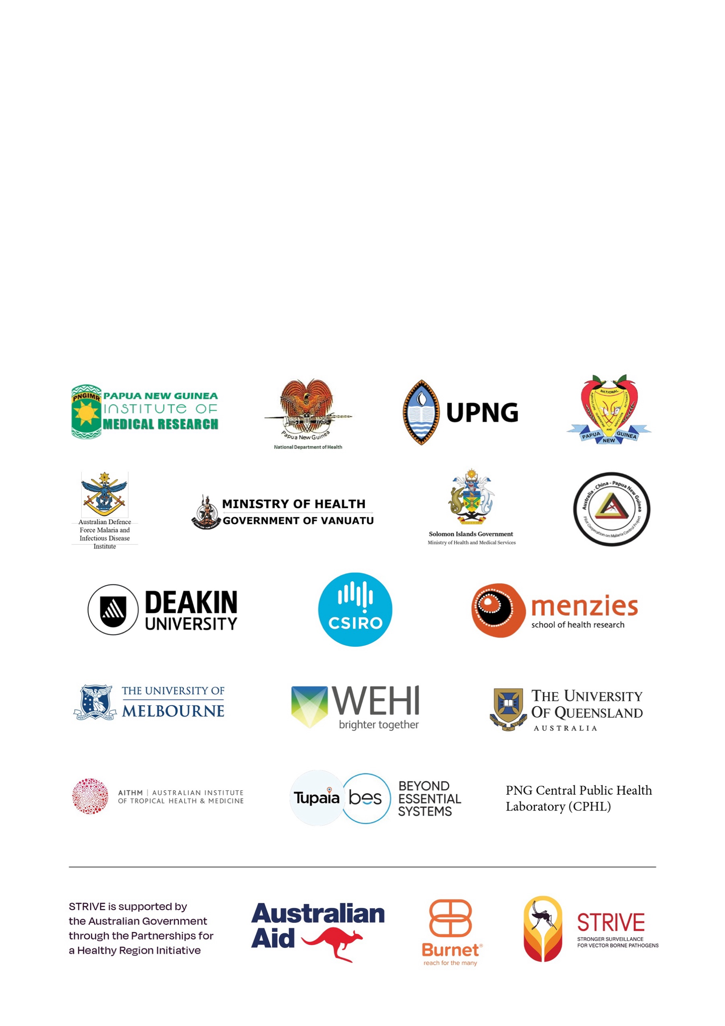
STRIVE Partner Acknowledgement
It’s important to recognise the immense contribution from STRIVE’s partners and leaders who continue to go above and beyond to ensure activities progressed throughout the project and strongly positioned the team to maximise opportunities and overcome challenges. By ensuring a fit for purpose approach to address identified strategic and operational priorities, the project has successfully transitioned into this new and exciting chapter of STRIVE.
Many of STRIVE’s partners (in PNG and Australia) support the project via in-kind contributions. Without these in-kind contributions (personnel, infrastructure, workforce capacity, just to name a few!) the program would not be able to achieve the breadth of outcomes, depth of impact and long-term sustainability it STRIVES for.

Annex A: Conferences &

Publications

Conferences
STRIVE PNG Partners have participated in international, regional, and local dissemination events in 2024 including:
Global Health Security, Sydney, Australia, 18th – 21st June 2024
American Society of Tropical Medicine and Hygiene, New Orleans, USA, 13th – 17th November 2024
PNG Medical Symposium, Mt Hagen, PNG, 1st – 6th September 2024
Vanuatu Health Research Symposium, Port Vila, Vanuatu, 2nd – 3rd October 2024
Annual Malaria Meeting, Port Moresby, PNG, 6th – 7th November 2024

Publications
To learn more about STRIVE’s work, please find below the list of journal articles/book chapters accepted or published:
Katusele M, Lagur S, et al. Insecticide resistance in malaria and arbovirus vectors in Papua New Guinea, 2017-2022. Parasit Vectors. 2022 Nov 14;15(1):426. doi: 10.1186/s13071-022-05493-3.
Lautu-Gumal D, Razook Z, Koleala T, Nate E, McEwen S, Timbi D, et al. Surveillance of molecular markers of Plasmodium falciparum artemisinin resistance (kelch13 mutations) in Papua New Guinea between 2016 and 2018. Int J Parasitol Drugs Drug Resist. 2021;16:188-93.
Mazhari R, Ruybal-Pesántez S, Angrisano F, et al. SARS-CoV-2 Multi-Antigen Serology Assay. Methods Protoc. 2021 Oct 9;4(4). doi: 10.3390/mps4040072. PubMed PMID: 34698238; PubMed Central PMCID: PMC8544427.
Goi, J, Koinari M, Muker A, Vinit, R, Pomat W, Williams DT, Karl S. Comparison of Different Mosquito Traps for Zoonotic Arbovirus Vectors in Papua New Guinea. Am J Trop Med Hyg. 2022, Jan 17;106(3):823-827. PMID: 35026726 doi: 10.4269/ajtmh.21-0640.
Farquhar R, Dori A, MacCana S, et al. STRIVE PNG: Using a partnership-based approach in implementation research to strengthen surveillance and health systems in PNG. BMC Health Research Policy and System. In Press.
Jonduo M, et al. Genomic Sequencing of Dengue Virus Strains Associated with Papua New Guinean Outbreaks in 2016 Reveals Endemic Circulation of DENV-1 and DENV-2. Am J Trop Med Hyg. 2022 Jul 5:tpmd211292. doi: 10.4269/ajtmh.21-1292. Epub ahead of print. PMID: 35895415.
Newland, J et al, COVID-19 and Its Impacts on Primary Health Services and Public Health Infectious Disease Programs in Papua New Guinea (2022)
Razook Z, Mehra S, Gilchrist B, Utama D, Lautu D, Fola A, Munro J, Menard D, Mueller I, Robinson LJ, Bahlo M and Barry AE. Real time, field deployable whole genome sequencing of malaria parasites using nanopore technology. Microbial Genomics, 2022, In Press.
Robinson LJ, Laman M, Makita L, Lek D, Dori A, Farquhar R, Vantaux A, Witkowski B, Karl S, Mueller I. Asia-Pacific International Center of Excellence in Malaria Research: Maximizing Impact on Malaria Control Policy and Public Health in Cambodia and Papua New Guinea. Am J Trop Med Hyg. 2022 Oct 11;107(4_Suppl):124-130. doi: 10.4269/ajtmh.21-1324. PMID: 36228920; PMCID: PMC9662209.
Schmidt, T. L., Endersby-Harshman, N. M., Van Rooyen, A. R., Katsuele, M., Vinit, R., Robinson, L., Laman, M., Karl, S., & Hoffmann, A. A. (n.d.). Global, asynchronous sweeps at multiple resistance genes in Aedes mosquitoes . Nature Ecology and Evolution.
(Pre-print) Kerry, Z., Farquhar, R. J., Mohamed, Y., Morgan, C., Dori, A. V., McEwen, S., Timbi, D., Porau, W., Tefuarani, N., Pomat, W., Makita, L., Laman, M., Robinson, L. Baseline assessment of front-line health system capacity in vector-borne disease surveillance and response in Papua New Guinea. Plos Global Public Health.

(Pre-print) Book Chapter: Dori, A, Farquhar, R,. et al. Partnership-based approach to infectious disease research in Papua New Guinea, Infectious Disease Work in a Changing World: People, Pathogens & Partnerships.

